
L.J. Institute of Computer
Application
L.J. University

Master of Computer Application - Cybersecurity Specialization

MCA Cyber Security

3rd Semester

Subject Name: Digital Forensics and Incident Response

Subject Code: MCACS303

Submitted To: Mr. Jigar Gajjar

Submitted By: Chudasama Vishal
Roll Number: E02
CERTIFICATE

This is to certify that Mr. Chudasama Vishal Bhimashibhai with enrollment number 25004401110069 Semester 3rd has successfully completed his/her laboratory experiments in the Digital Forensics and Incident Response (MCACS303) from the department of MCA Cyber Security during the academic year 2025 - 2028

Date of Submission:

Staff in charge: Mr. Jigar Gajjar

TABLE OF CONTENT

Sr. No | Experiment Title | Page No | Date of Completion | Marks (Out of 10) | Sign
1 | Evidence Acquisition with FTK Imager | 4
2 | Autopsy: Deleted File Recovery & Activity Timeline | 9
3 | Windows Registry Forensic Analysis | 14
4 | Windows Event Log Analysis from own computer’s Event Viewer | 20
5 | Network Forensics with Wireshark | 24
6 | Emall Forensics | 31
7 | Hash Comparison Using PowerShell | 37
8 | USB Device History | 42
9 | NTFS MACB Timestamps and USN Journal | 45
10 | RAM Acquisition and Memory Forensics | 51

Practical-1 Evidence Acquisition with FTK Imager

AIM: “Create a forensic image of an instructor-provided USB device, verify its integrity using hash values, and document chain of custody.”

Procedure
Step 1: Install FTK Imager
FTK Imager was installed and launched to perform forensic evidence acquisition.
- Download FTK Imager (free) from the official Exterro website.
- Install and launch the application.
- Confirm the application opens successfully, showing the main FTK Imager window with File, View, Mode, Help menus.
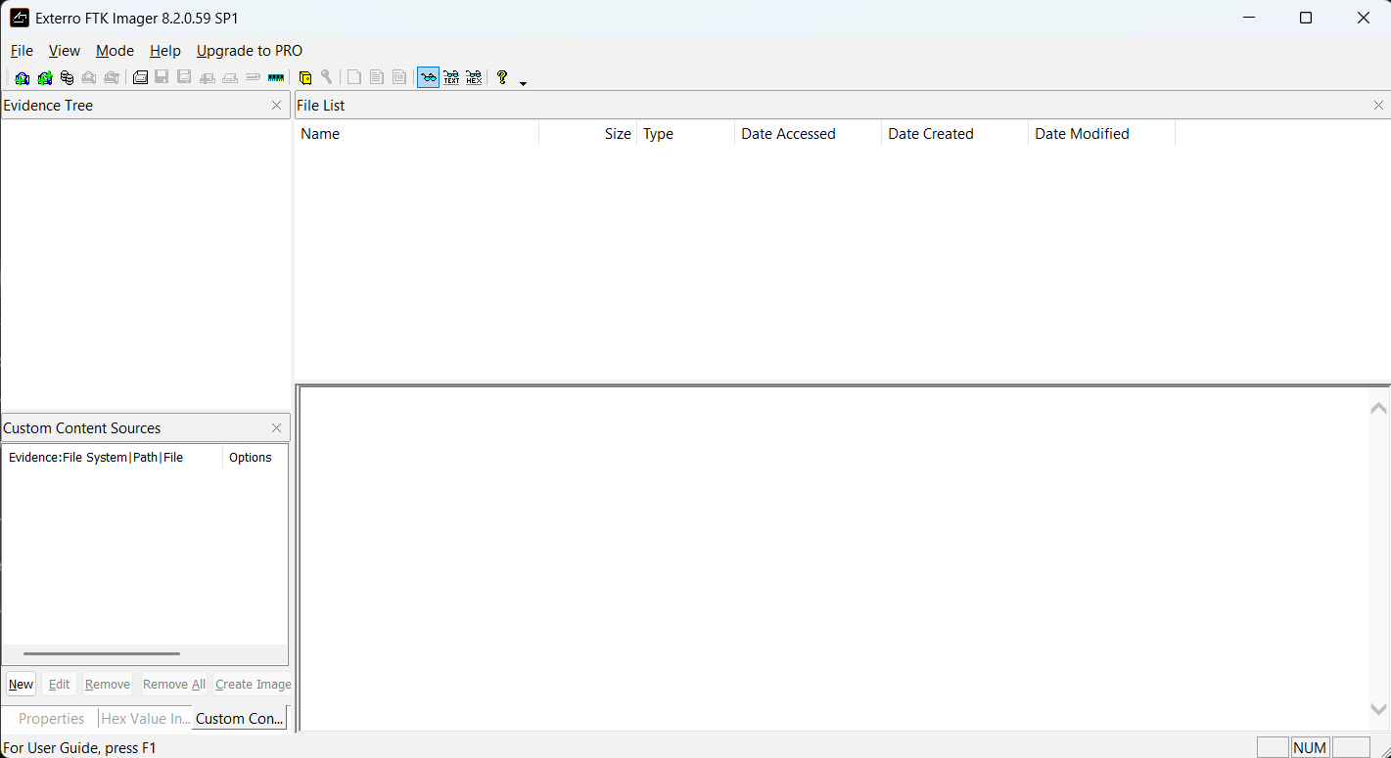
Figure 1: FTK Imager 8.2.0.59 SP1 launched and ready for forensic evidence acquisition.

Step 2: Capture Volatile Memory (RAM Capture)
An attempt was made to capture the system's volatile memory (RAM) using FTK Imager's built-in memory acquisition feature to preserve live system state data before it is lost on shutdown.
- FTK Imager was run with Administrator privileges.
- Windows Security → Device Security → Core Isolation → Memory Integrity was disabled and the laptop was restarted to remove potential driver-loading restrictions.
- In FTK Imager, File → Capture Memory was selected, with destination set to D:\memdump.mem.
- Capture Memory was clicked to begin acquisition.
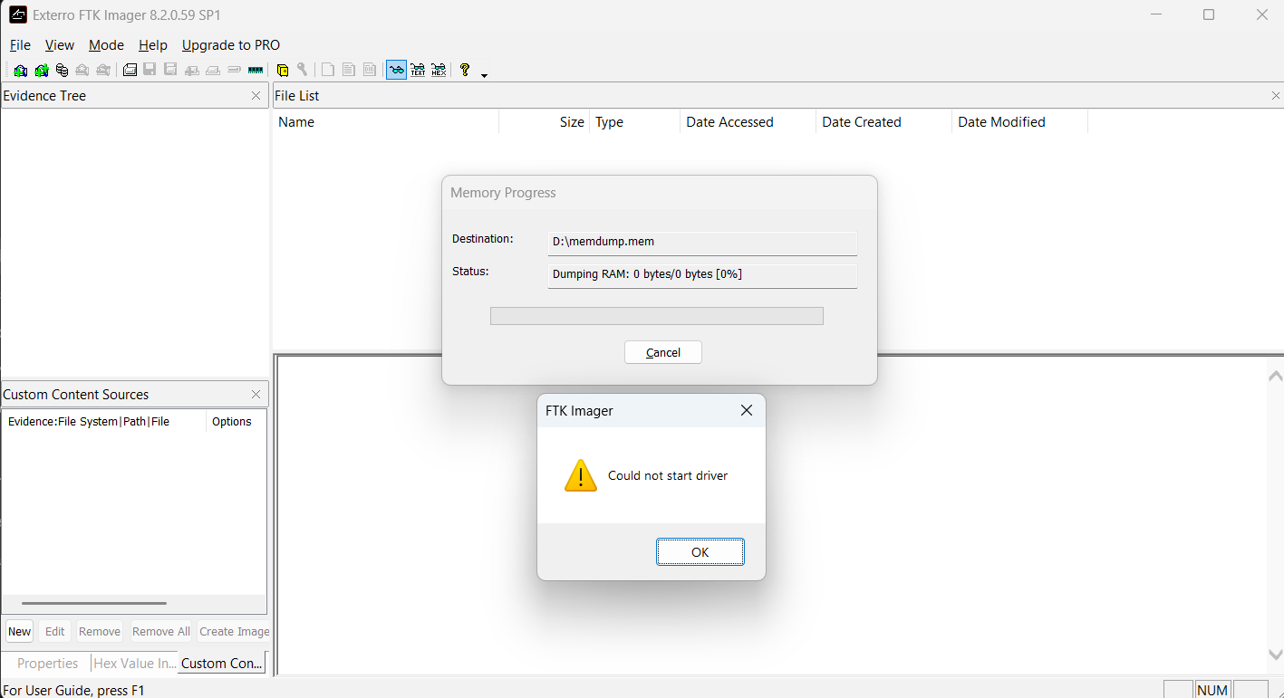
Figure 2: FTK Imager RAM capture attempt failing with "Could not start driver" error despite Administrator privileges and Memory Integrity disabled, indicating a kernel driver compatibility restriction on the host system.
POC Explanation
The "Could not start driver" error indicates that FTK Imager's kernel-level memory acquisition driver failed to load on this system, even after addressing the two most common causes — insufficient privileges (resolved via Administrator execution) and Core Isolation/Memory Integrity blocking (disabled prior to the attempt). This points to a deeper compatibility issue between FTK Imager 8.2.0.59's legacy driver and the current Windows build's Driver Signature Enforcement / kernel security policies, which increasingly restrict unsigned or outdated third-party drivers from accessing physical memory directly. This is a legitimate and commonly documented limitation in real-world forensic practice: volatile memory acquisition tools frequently fail on modern, hardened Windows systems, and analysts must note such failures accurately rather than assume the tool itself is broken. The failure was documented as evidence of a driver-level access restriction rather than a procedural error.

Step 3: Create Forensic Image of the USB Device
A forensic image of the USB pendrive (Physical Drive 1, 16GB HP pendrive) was created using FTK Imager in E01 format, capturing a complete bit-by-bit copy of the device for forensic analysis.

- In FTK Imager, File → Create Disk Image → selected Physical Drive → chose \\.\PHYSICALDRIVE1.
- Selected image type E01, filled in Evidence Item Information.
- Set destination to D:\Cyber\Image\pendrive_image, Image Fragment Size = 0 (single file), Compression = 6.
- Enabled "Verify images after they are created" and clicked Start.
- Waited for imaging and automatic verification to complete.

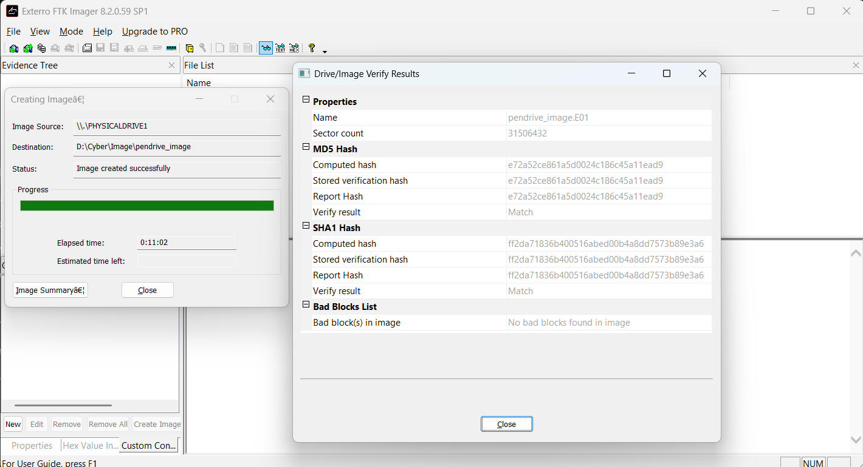
Figure 3: FTK Imager Drive/Image Verify Results confirming matched MD5 and SHA1 hash values with no bad blocks, validating successful forensic image creation of the USB pendrive.
The image was created successfully at D:\Cyber\Image\pendrive_image.E01 (Sector count: 31,506,432), with a total elapsed time of 0:11:02. The Drive/Image Verify Results confirmed:
- MD5: Computed hash = Stored verification hash = Report Hash = e72a52ce861a5d0024c186c45a11ead9 → Match
- SHA1: Computed hash = Stored verification hash = Report Hash = ff2da71836b400516abed00b4a8dd7573b89e3a6 → Match
- Bad Blocks: No bad blocks found in image.

POC Explanation
The successful match between the computed hash, stored verification hash, and report hash for both MD5 and SHA1 algorithms confirms that the forensic image is a byte-for-byte, unaltered copy of the original pendrive, with no data corruption introduced during the acquisition process. The absence of bad blocks further confirms clean, error-free sector-by-sector acquisition across the entire 16GB physical device. This dual-hash verification is critical in digital forensics, as it establishes the image's evidentiary integrity — proving in court or examination that the analyzed image faithfully represents the original evidence at the time of seizure.
Step 4: Verify Integrity via Hash Values (MD5/SHA1)
While hash verification occurred automatically during imaging (Step 3), the integrity of the acquired evidence was further confirmed by reviewing the auto-generated hash report file created by FTK Imager alongside the disk image.
- Navigate to the destination folder D:\Cyber\Image\ in File Explorer.
- Locate pendrive_image.E01.txt, generated automatically alongside the .E01 image file.
- Open the .txt report and review the Physical Drive Information and Computed Hashes sections.
- Compare the recorded MD5/SHA1 values against the Drive/Image Verify Results obtained in Step 3 to confirm they match exactly.
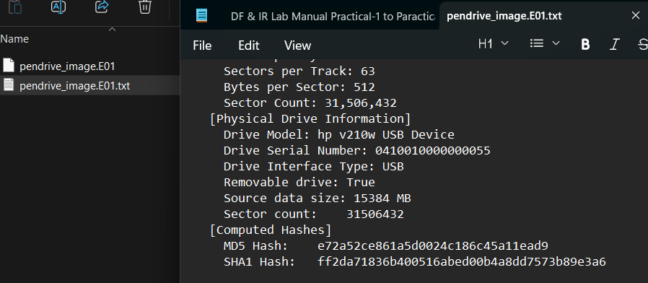
Figure 4: FTK Imager-generated hash report (pendrive_image.E01.txt) showing device information and computed MD5/SHA1 hash values confirming evidence integrity.
POC Explanation
The hash report independently documents the source device's identifying details (model, serial number, interface, size) alongside the computed MD5 and SHA1 checksums, providing a persistent, file-based record of the evidence's integrity beyond the live application session. The exact match between the report file's hashes and the in-application verification results (Step 3) confirms the acquired image is a forensically sound, unaltered copy of the original pendrive. This documented baseline is essential to chain-of-custody: any future re-hashing of the image (e.g., before court submission or peer review) can be compared against these recorded values to prove the evidence remained unmodified since acquisition.

Step 5: Complete Chain-of-Custody
Case Number | Practical1_EvidenceAcquisition
Evidence Number | USB-01
Description of Evidence | HP v210w 16GB USB Pendrive
Drive Serial Number | 0410010000000055
Interface Type | USB (Removable)
Source Data Size | 15,384 MB
Sector Count | 31,506,432
Date/Time of Acquisition | 23-08-2026 11:13 PM
Location of Acquisition | Ahmedabad, Gujarat, India
Acquisition Tool | FTK Imager 8.2.0.59 SP1
Image Filename | pendrive_image.E01
Image Format | E01 (EnCase), Compression Level 6
MD5 Hash | e72a52ce861a5d0024c186c45a11ead9
SHA1 Hash | ff2da71836b400516abed00b4a8dd7573b89e3a6
Verification Result | Match (No bad blocks found)
Storage Location of Image | D:\Cyber\Image\
Purpose / Reason for Acquisition | Practical-1: Evidence Acquisition Lab (DF & IR)
Observation
- FTK Imager was successfully installed and used for forensic evidence acquisition.
- RAM capture failed due to a "Could not start driver" error, even after running as Administrator and disabling Memory Integrity — indicating a kernel driver compatibility restriction on the host system.
- A forensic image of the 16GB HP USB pendrive (Physical Drive) was successfully created in E01 format with Best compression.
- Hash verification confirmed matching MD5 and SHA1 values between the computed hash, stored verification hash, and report hash, with no bad blocks detected.
- The auto-generated hash report file independently confirmed the same MD5/SHA1 values and device details (model, serial number, source size).
- A Chain-of-Custody form was completed, documenting evidence details, acquisition tool, hash values, and examiner information.
Conclusion
Evidence acquisition was performed using FTK Imager as part of this practical. While volatile memory (RAM) capture could not be completed due to a driver-level restriction on the host system, the forensic image of the USB pendrive was successfully created and verified, with matching MD5 and SHA1 hash values confirming the integrity of the acquired evidence. Completion of the Chain-of-Custody form further ensured proper documentation of evidence handling. These results demonstrate the standard forensic acquisition and integrity-verification workflow, including a realistic instance of a real-world tool limitation encountered and documented during the process.

Practical-2 Autopsy: Deleted File Recovery & Activity Timeline

AIM: “Examine an instructor-provided forensic disk image, identify deleted files and user activity artefacts, and build a chronological timeline.”

Procedure
Step 1: Load the Pre-Seeded Forensic Image
For this practical, a pre-seeded forensic image (HASAN2.E01) was already provided within the TryHackMe lab environment, with an Autopsy case already created and the image loaded, ingest modules run, and analysis results populated.
- Open Autopsy on the provided TryHackMe lab machine.
- The pre-existing case was already loaded with the disk image HASAN2.E01 added as the data source.
- Reviewed the Data Sources table to confirm image details: Type, Size, Sector Size, Timezone, and Device ID.
- Selected the data source and reviewed the Results tab, confirming description: "OS Drive (Windows 10 Home)".
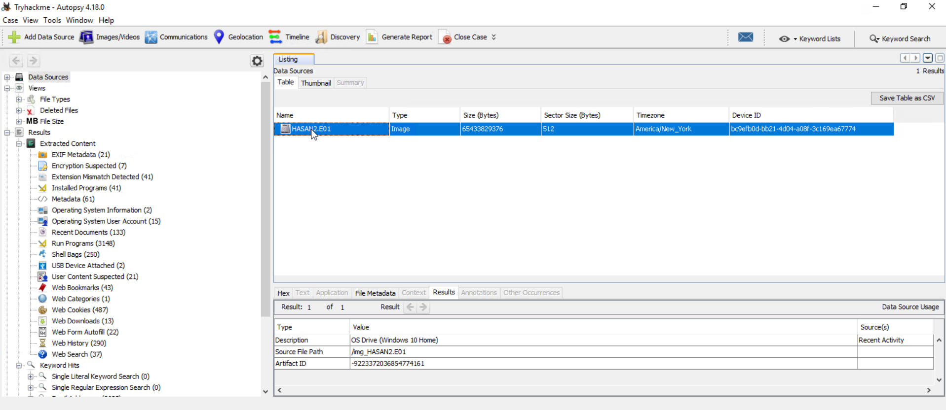
Figure 1: Pre-seeded forensic image HASAN2.E01 loaded in Autopsy, confirmed as a Windows 10 Home OS drive with populated Recent Activity artefact categories.
POC Explanation
The successful loading and description of HASAN2.E01 as a genuine Windows 10 Home OS drive image confirms this is a full operating system disk image, unlike smaller test images limited to isolated file recovery. The presence of populated categories such as Web History, Recent Documents, and USB Device Attached in the Extracted Content tree — visible immediately after ingest — confirms that this image contains real user activity artefacts, making it suitable for fulfilling all requirements of this practical: deleted file recovery, recent activity extraction, and timeline reconstruction.

Step 2: Analyze the File System and Recover Deleted Files
The Deleted Files category was analyzed in Autopsy to identify files removed from the file system but still recoverable from the disk image, with select files extracted to the Desktop for independent verification.
- In the left tree, expanded Deleted Files → File System (4717) → All (4717).
- Reviewed the Table view listing all recovered deleted files, along with their Modified, Change, and Access timestamps.
- Selected file and Right-clicked files → Extract File(s) → saved to Desktop.
- Verified extracted files appear on the Desktop as standalone,independently accessible files.
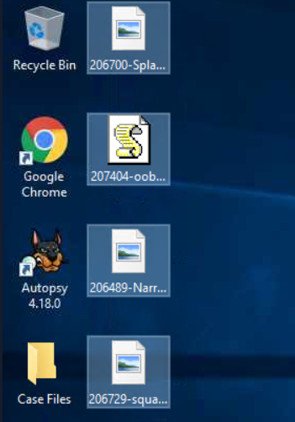
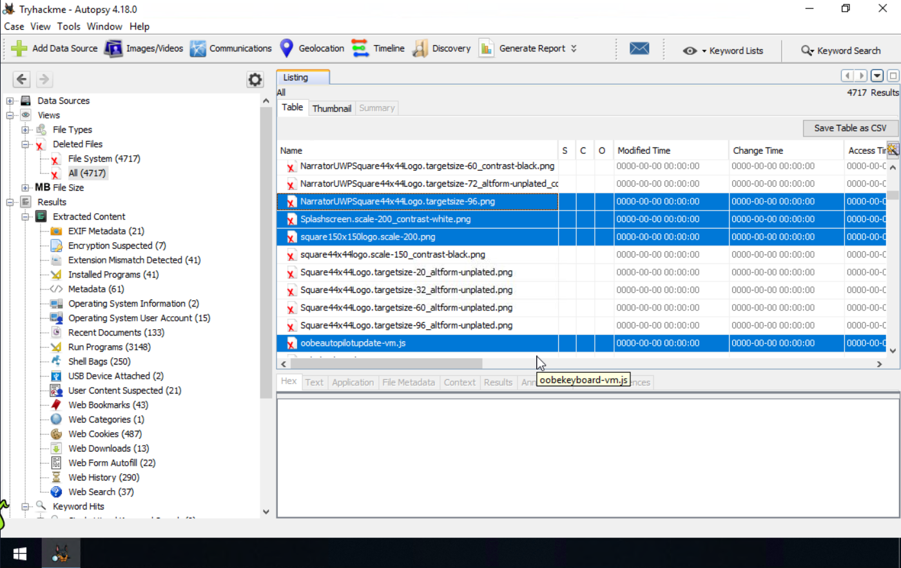
Figure 2: Deleted Files view in Autopsy (4,717 recovered entries) alongside the corresponding recovered files successfully extracted to the Desktop, confirming standalone accessibility outside Autopsy.
POC Explanation
The Deleted Files table shows all recovered entries with null (0000-00-00) timestamps, and the same selected files appear as standalone icons on the Desktop, confirming they were successfully extracted outside Autopsy.

Step 3: Extract Recent Activity Artifacts
The Extracted Content generated from the HASAN2.E01 forensic image was examined in Autopsy to identify recent user and system activity.
- Expand Results → Extracted Content in the Autopsy navigation tree.
- Review the populated recent-activity categories.
- The following artefact categories were identified:
  - Recent Documents (133)
  - USB Device Attached (2)
  - Web History (290)
  - Web Downloads (13)
  - Web Bookmarks (43)
  - Web Cookies (487)
  - Run Programs (3148)
  - Shell Bags (250)
- Select Web History and examine the recorded activity, including the URL, Date Accessed, Referrer URL, and Program Name.
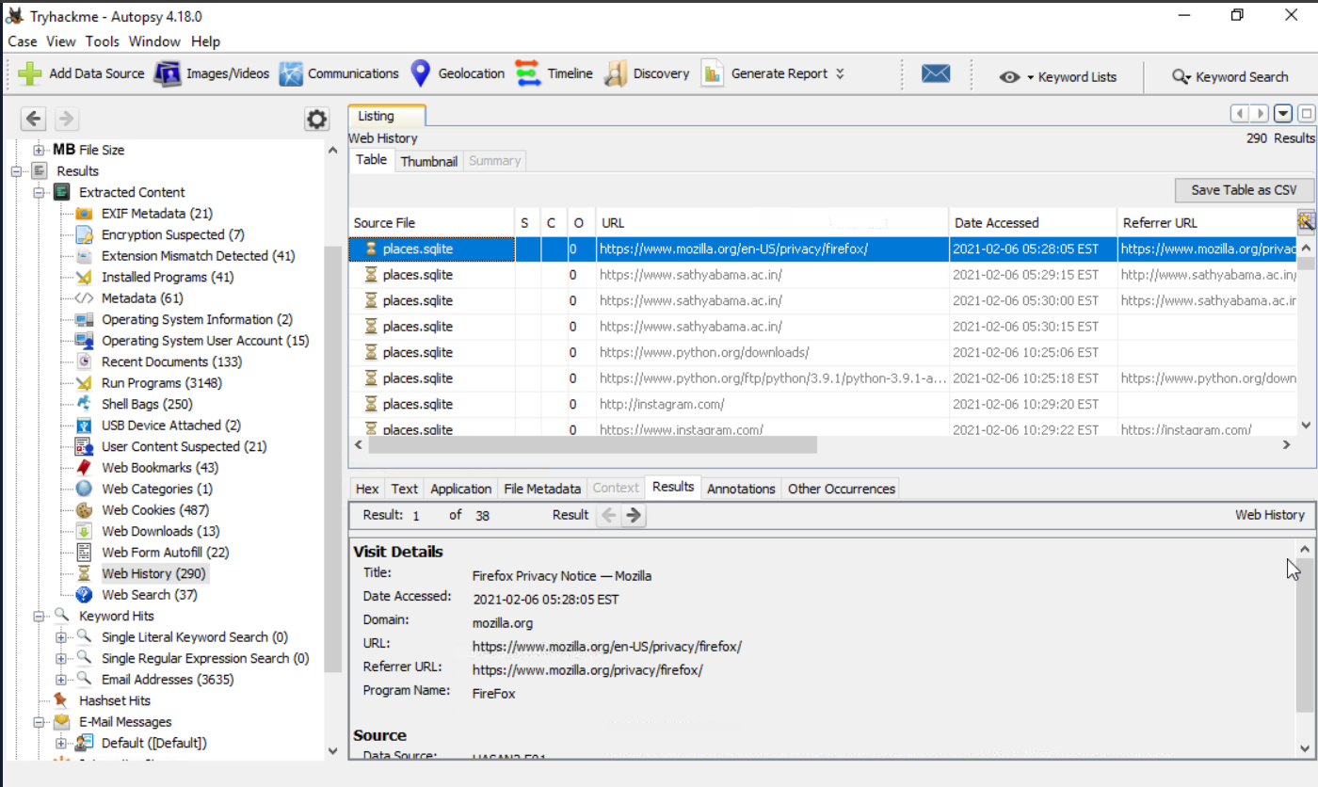
Figure 3: Web History artefacts recovered from places.sqlite showing browsed URLs, access timestamps, and visit details.
POC Explanation
The populated Extracted Content categories demonstrate that the forensic image contains recoverable user-activity artefacts. The Web History record provides a specific application, URL, and timestamp, which can be correlated with other artefacts to reconstruct user activity chronologically.

Step 4: Build and Analyze the Chronological Activity Timeline
The Timeline feature in Autopsy was used to correlate and analyze the timestamped forensic events extracted from the HASAN2.E01 image.
- Open Timeline from the Autopsy toolbar.
- Review the events in Counts view to observe their chronological distribution.
- Examine the displayed time range and event distribution.
- Review the timeline for the period containing the available user and system activity.

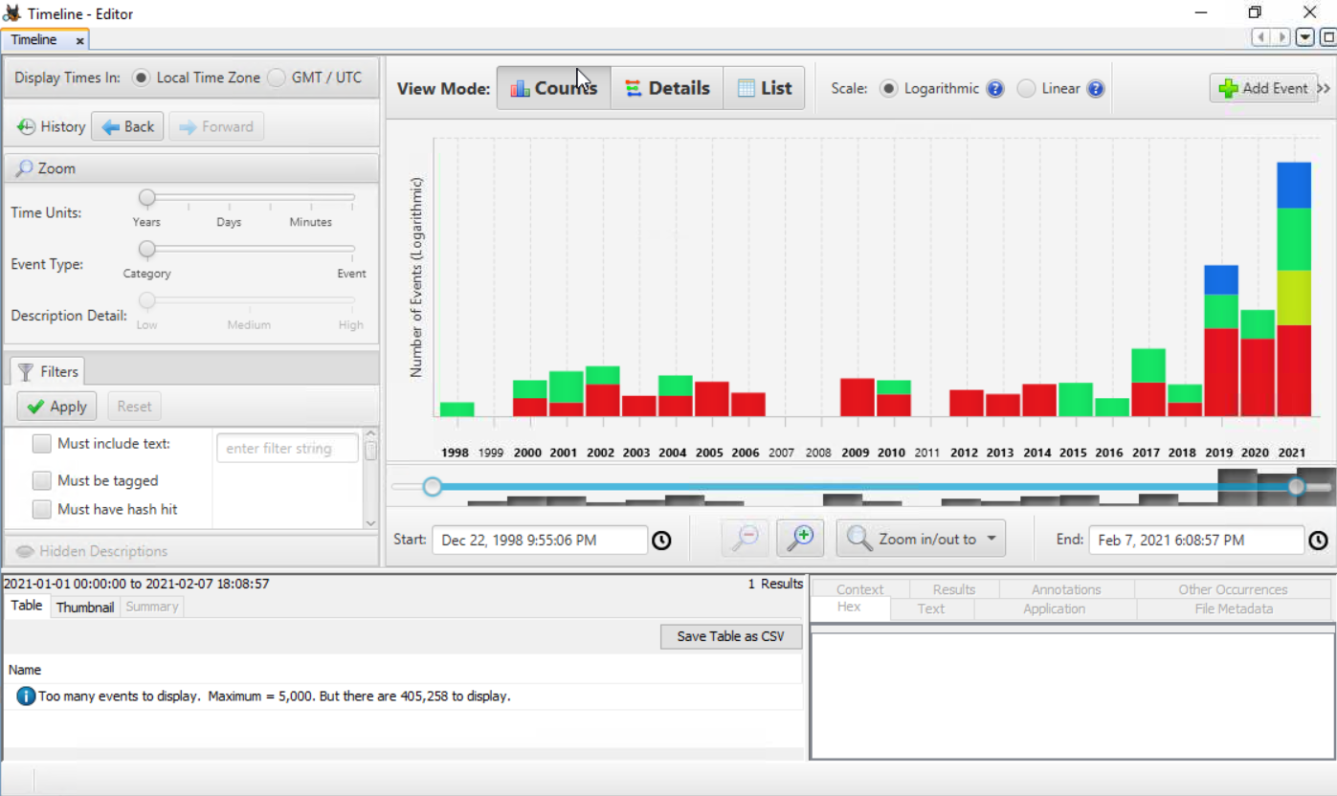
Figure 4: Autopsy Timeline displaying the chronological distribution of 405,258 forensic events from the HASAN2.E01 image.
POC Explanation
The Timeline contains a large number of timestamped events distributed from 1998 to 2021. For the selected analysis period. The displayed timeline extends to 7 February 2021, with concentrated activity visible during 2019–2021.
The Timeline consolidates timestamped forensic events into a chronological representation, allowing different activities to be correlated by date and time. The presence of 405,258 events demonstrates that the HASAN2.E01 image contains substantial temporal evidence suitable for reconstructing system and user activity.
Observation:
- 4,717 deleted files were recovered from the disk image under Deleted Files → File System, all showing null (0000-00-00) timestamps consistent with NTFS deleted directory entry recovery.
- Selected recovered files were successfully extracted to the Desktop, confirming standalone accessibility outside Autopsy.
- 290 Web History entries were recovered from places.sqlite, showing browsed URLs, access timestamps, and referrer chains via the FireFox browser.
- Autopsy's Timeline feature displayed event activity spanning December 1998 to February 2021, with the highest concentration of events in 2021.
- The 2021 timeline spike correlated directly with the Web History access timestamps recovered in Step 3, confirming consistent chronological evidence across artefacts.

Conclusion:
The forensic analysis of the pre-seeded disk image (HASAN2.E01) was successfully performed using Autopsy. Deleted file recovery yielded thousands of recoverable entries, several of which were independently verified through extraction. Recent activity artefacts, specifically Web History, provided detailed browsing evidence with exact timestamps. The Timeline feature further consolidated these findings into a chronological view, confirming that recovered artefacts aligned consistently in time. Together, these results demonstrate a complete deleted file recovery and activity timeline reconstruction workflow using Autopsy.

Practical-3 Windows Registry Forensic Analysis

AIM: “Examine Windows Registry artefacts to identify application execution traces, USB device history, recent documents, and possible persistence entries.”

Procedure
Step 1: Logs Load Windows Registry Hives
Registry Explorer 2026.5.0.0 was used to load the Windows Registry hive files required for forensic analysis. Since the Registry hive files under the Windows system directories are protected, Registry Explorer was started with Administrator privileges.
Action
- Right-click Registry Explorer and select Run as administrator.
- In Registry Explorer, select File → Load Hive.
- Load the following Registry hives from their respective locations:
SOFTWARE | C:\Windows\System32\config\SOFTWARE
SYSTEM | C:\Windows\System32\config\SYSTEM
NTUSER.DAT | C:\Users\vish\NTUSER.DAT
Amcache.hve | C:\Windows\AppCompat\Programs\Amcache.hve
- After loading, verify that each hive is displayed in Registry Explorer and its Registry tree is available for analysis.
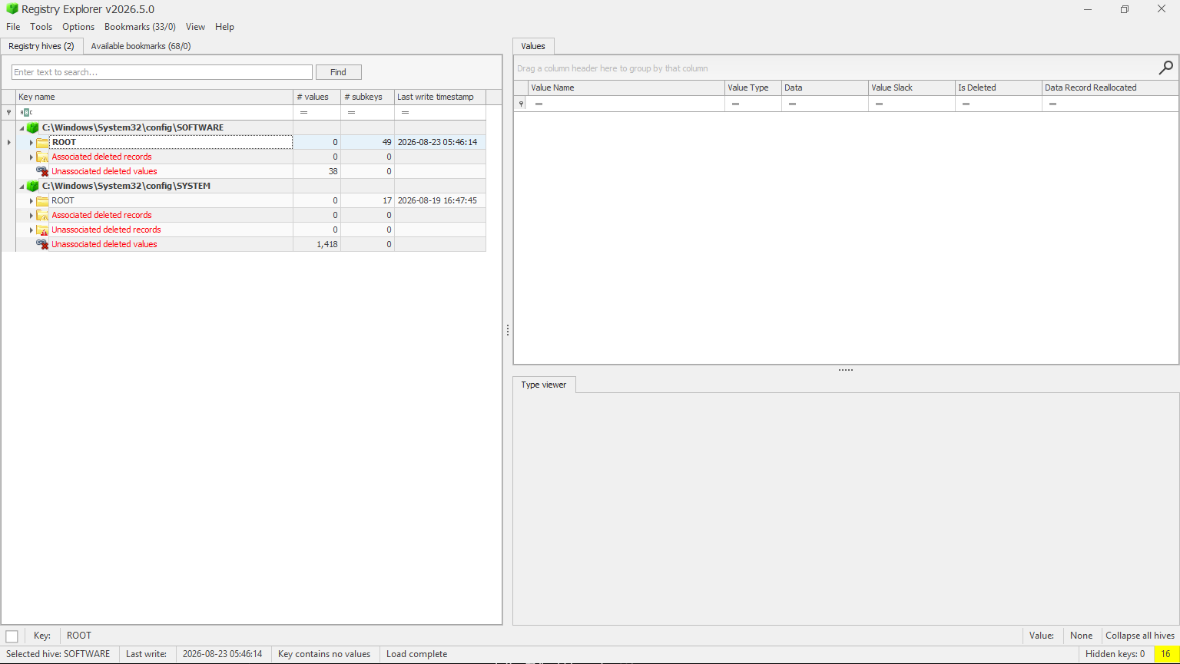
Figure 5: Registry Explorer running with administrator privileges and loaded Windows Registry hives for forensic analysis.
POC Explanation
The Registry hives contain different categories of forensic information. NTUSER.DAT provides user-specific artefacts, SYSTEM contains system and hardware-related information, and SOFTWARE contains system-wide application and configuration information. Amcache.hve is retained as supporting application evidence.

Step 2: Analyze Program Execution History – UserAssist (NTUSER.DAT)
The NTUSER.DAT hive is examined for Registry artefacts that record evidence of programs executed by the user. The UserAssist Registry keys are used for this analysis.
Action
In Registry Explorer, select the loaded NTUSER.DAT hive and navigate to:
NTUSER.DAT\Software\Microsoft\Windows\CurrentVersion\Explorer\UserAssist
Select the GUID subkey and open the Count subkey under it.
Under UserAssist, expand the available GUID subkeys and locate the Count subkey.
Select Count and examine the values displayed in the right pane.
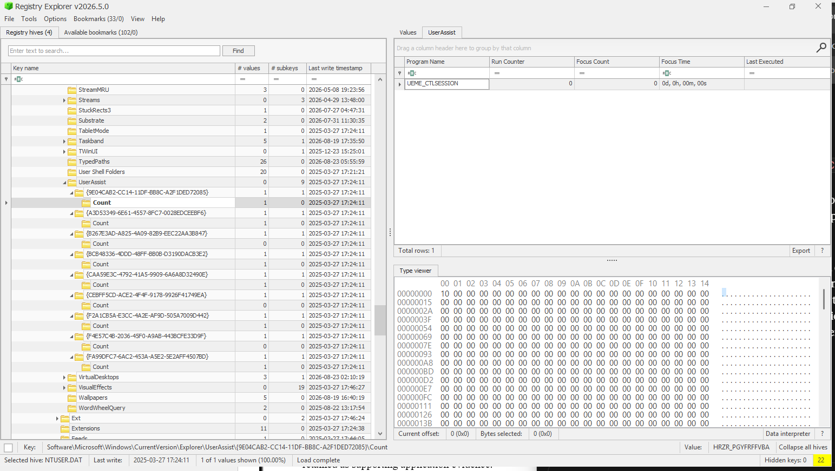
Figure 6: UserAssist registry key showing only the default UEME_CTLSESSION placeholder with no recoverable program execution entries.
POC Explanation
UEME_CTLSESSION is a default session-tracking value maintained by Windows Explorer and does not represent an executed application; it is present even when no user program-launch data has been recorded. Since none of the nine UserAssist GUID subkeys on this NTUSER.DAT hive contain a decoded program path with a non-zero Run Counter or Last Executed timestamp, it is concluded that the UserAssist artefact on this system does not hold recoverable program execution history

Step 3: Program Execution History – Shimcache/Amcache
Amcache.hve records metadata about executed applications, including file path, SHA-1 hash, and first execution timestamp, even for programs that have been deleted. This artefact is more reliable than UserAssist for establishing program execution history, as it is maintained at the system level and is harder to clear.
Action
- In Registry Explorer, select the loaded Amcache.hve hive from the Registry hives tab
- Navigate to the following path: Amcache.hve\Root\InventoryApplicationFile
- Identify a few relevant entries (e.g., non-system executables) showing file path and timestamp to use as evidence.
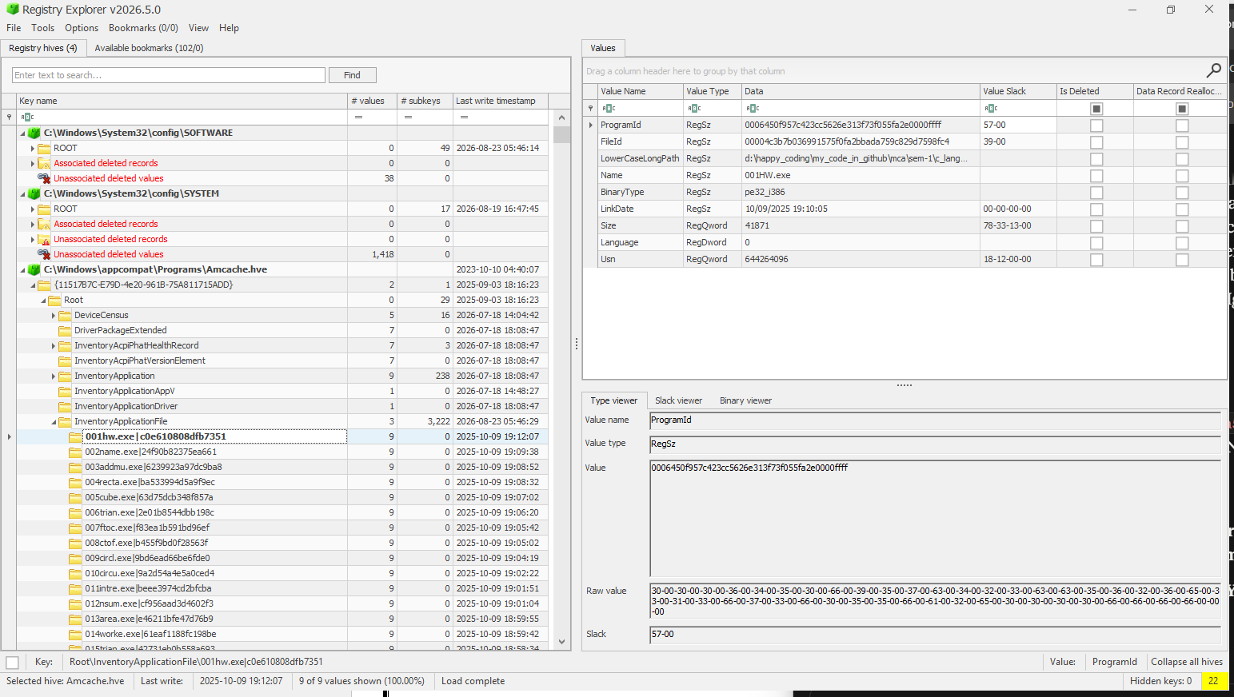
Figure 7: Amcache InventoryApplicationFile entry for a user-compiled executable (001HW.exe), confirming Amcache's ability to record execution metadata for self-created programs.
POC Explanation
This entry demonstrates that Amcache tracks execution artefacts for user-compiled/self-created executables, not only installed commercial applications. The file 001HW.exe, located in a personal C programming practice directory (d:\happy_coding\...\c_lang...), is recorded with its SHA-1 hash (FileId), exact file path, and LinkDate representing the binary's compilation timestamp. The presence of this entry confirms that Amcache captures execution metadata for any PE executable run on the system, regardless of its origin (installed software, portable tool, or self-compiled program), making it a comprehensive artefact for reconstructing a complete program execution history — including academic/development activity in this case.

Step 4: USB Device Connection Analysis (SYSTEM Hive)
The SYSTEM hive retains records of USB storage devices connected to the system, including vendor, product, serial number, and connection timestamps.
Action
- Select the SYSTEM hive in Registry Explorer.
- Navigate to: SYSTEM\CurrentControlSet\Enum\USBSTOR
- Expand the device subkey and its Serial Number subkey. Note the FriendlyName and Serial Number.
- For connection timestamps, check
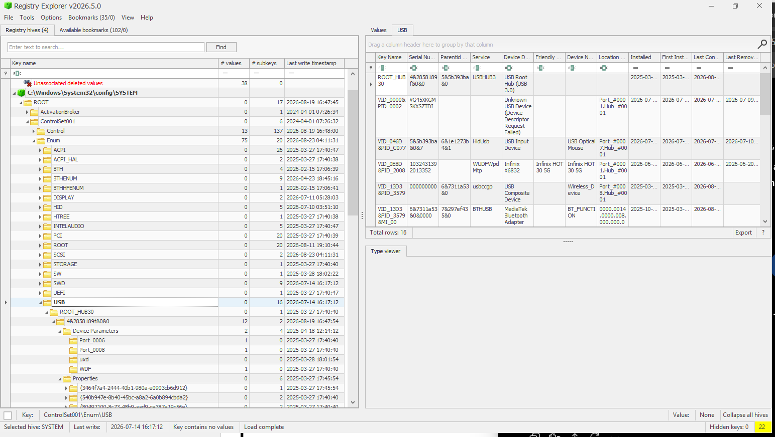
Figure 8: Enum\USB registry data showing an Infinix HOT 30 5G device connection with serial number and connection timeline.
POC Explanation
The Enum\USB key logs every USB device connected to the system, identified by Vendor ID (VID) and Product ID (PID), along with its unique serial number. The First Installed timestamp indicates when the device was first connected, while Last Connected and Last Removed establish a timeline of its most recent usage. This confirms that an Infinix HOT 30 5G smartphone was connected to the system via USB, providing device attribution and a connection timeline. key evidence in USB-based data exfiltration or device usage investigations.

Step 5: Persistence Mechanisms - Run/RunOnce Keys
Run and RunOnce keys store programs configured to execute automatically at user logon or system startup, commonly used for legitimate startup apps and, in malicious cases, for persistence.
Action
- Select the SOFTWARE hive (system-wide) and NTUSER.DAT hive (user-specific) in Registry Explorer.
- Navigate to:
SOFTWARE\Microsoft\Windows\CurrentVersion\Run
SOFTWARE\Microsoft\Windows\CurrentVersion\RunOnce
NTUSER.DAT\Software\Microsoft\Windows\CurrentVersion\Run
- Review the listed values — each entry's Name and Data show the program set to auto-start and its executable path.
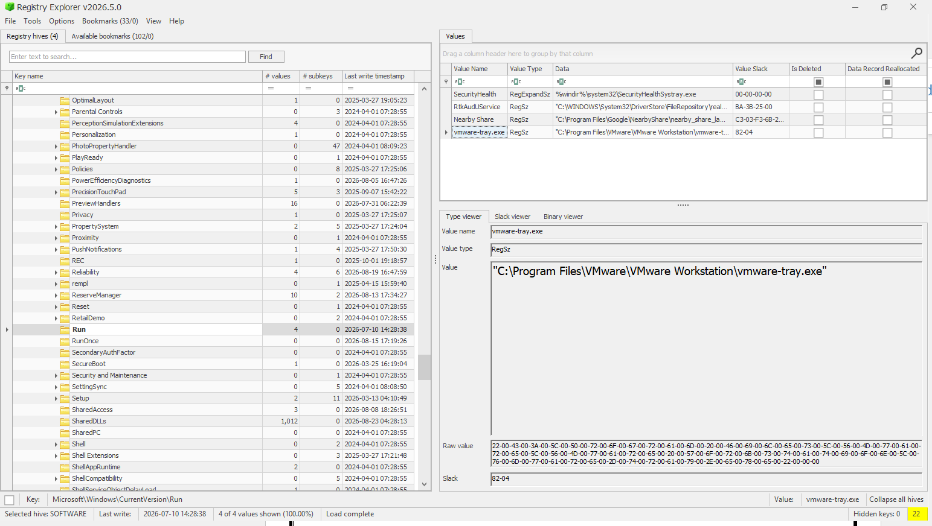
Figure 9: Run registry key showing configured auto-start applications for persistence analysis.
POC Explanation
Entries under the Run key execute automatically at every user logon, establishing persistence for the listed applications. The identified programs (Windows Security health monitor, Realtek audio service, Google Nearby Share, and VMware Workstation tray utility) correspond to legitimate installed software rather than suspicious or unknown binaries, indicating standard application persistence rather than malicious activity on this system. The empty RunOnce key confirms no single-execution startup entries are pending.
The NTUSER.DAT\Software\Microsoft\Windows\CurrentVersion\Run key (user-specific hive) was also examined and contains:
"C:\Program Files (x86)\Microsoft\Edge\Application\msedge.exe" --win-session-start

Step 6: Record and Document Forensic Artefacts
The extracted Registry artefacts are consolidated to document the findings obtained from the SYSTEM, SOFTWARE, and NTUSER.DAT hives.

The analysis produced evidence in the following three areas:
Forensic Area | Registry Hive | Artefact / Finding
Program/Application history | Amcache.hve | Application records under InventoryApplication
USB device connection | SYSTEM | USB device records, including Infinix HOT 30 5G
Persistence | SOFTWARE, NTUSER.DAT | Run/RunOnce startup entries
The persistence analysis identified legitimate startup entries including Windows Security health monitor, Realtek audio service, Google Nearby Share, VMware Workstation tray utility, and a user-level Microsoft Edge startup entry.

Observation
The Windows Registry hives were examined using Registry Explorer 2026.5.0.0. The analysis identified forensic artefacts related to application history, USB device connections, and persistence mechanisms.
- Program/Application History: Application records were identified in Amcache.hve under InventoryApplication.
- USB Device Connection: The SYSTEM hive contained USB device records, including an Infinix HOT 30 5G device with associated connection information.
- Persistence Mechanisms: SOFTWARE and NTUSER.DAT contained Run/RunOnce startup entries associated with installed applications.

Conclusion
Windows Registry forensic analysis successfully extracted relevant artefacts from the Registry hives. The findings provided evidence of application history, USB device usage, and configured startup mechanisms, demonstrating the usefulness of Windows Registry data in digital forensic investigations.

Practical-4 Windows Event Log Analysis

AIM: “Identify significant Windows event IDs from Event Viewer and explain what each event can indicate during an investigation.”

Procedure
Step 1: Open Windows Event Viewer and Access System Logs
Windows Event Viewer is used to examine event records generated by the Windows operating system. the System log is accessed to identify significant event IDs recorded on the local computer.
Action
- Press Win + R.
- Enter: eventvwr.msc
- Press Enter.
- In Event Viewer, navigate to: Windows Logs System
- Select System from the left panel.
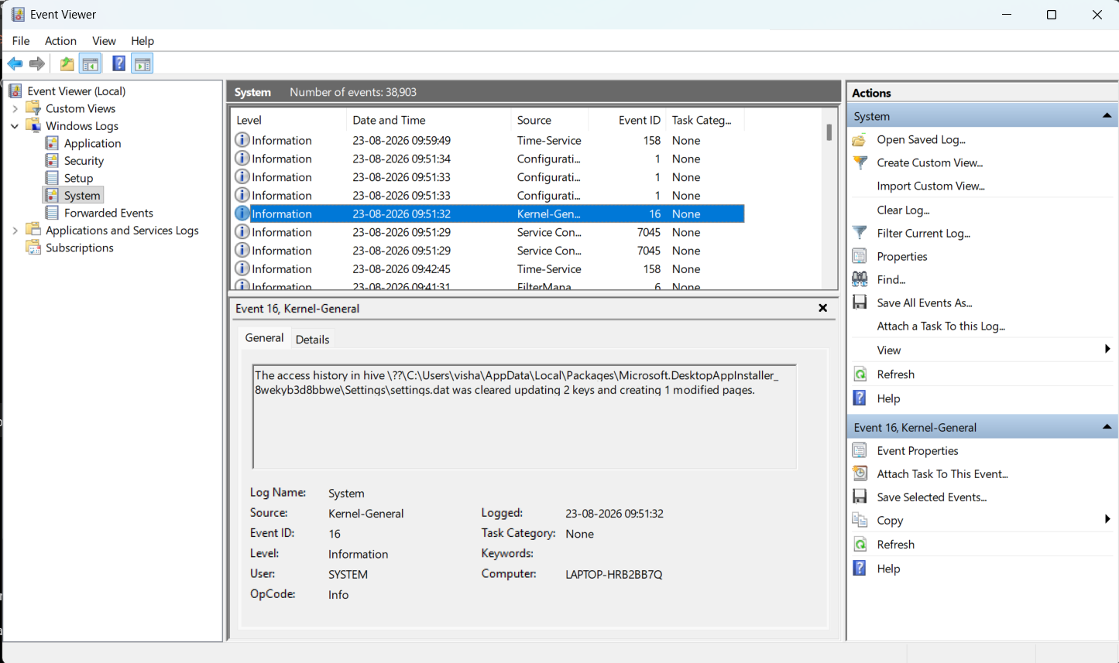
Figure 10: Windows Event Viewer displaying the System event log of the local computer.
Screenshot Explanation
The System event log contains records generated by Windows system components, services, drivers, startup/shutdown operations, and other system-level activities.
The System log provides the primary evidence source for identifying and analyzing important Windows event IDs generated by the local computer.
Step 2: Identify Critical and Important Event IDs
The System log is examined to identify events having Critical, Error, and Warning severity levels. These events are useful for forensic analysis because they can indicate system failures, unexpected shutdowns, service problems, driver issues, or other significant system activity.
Action
In the System log:
- Observe the Level column.
- Identify events marked: Critical, Information, Error, Warning
- Note their corresponding Event ID, Source, and Date and Time.
- Prefer event IDs that occur repeatedly or provide meaningful forensic information.
For easier identification, the log can be filtered using:
Right-click System → Filter Current Log...
Under Event level, select: Critical
Click OK.
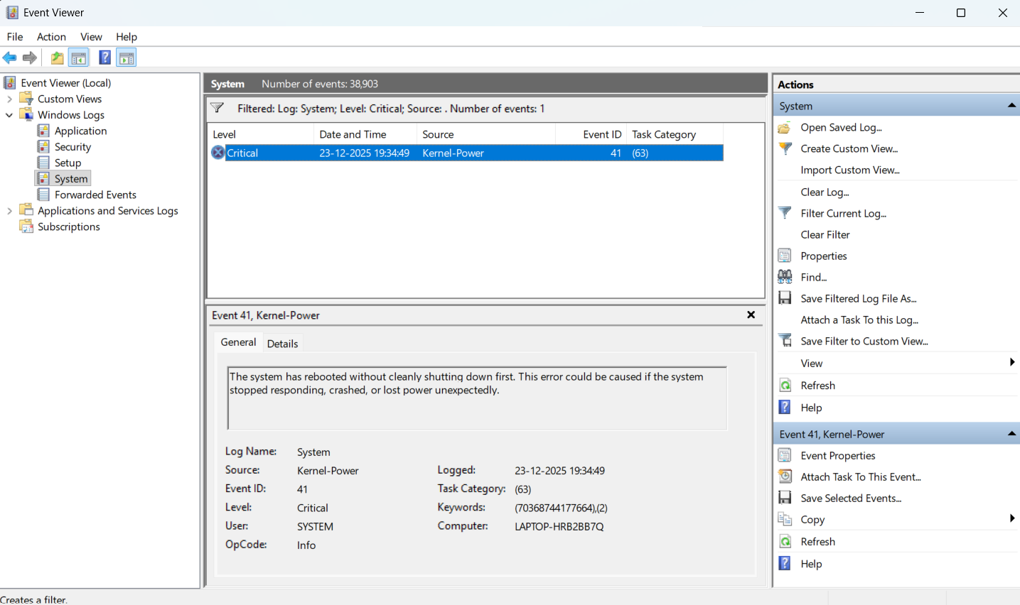
Figure 11: Critical Event ID 41 (Kernel-Power) identified from the Windows System event log.
POC Explanation
The screenshot confirms that Event ID 41 (Kernel-Power) is a Critical event recorded in the local System log. It is relevant for the practical because it provides evidence of an unexpected system restart or shutdown.

Step 3: Examine the Critical Event Details
Since the Event Viewer contains one Critical event (Event ID 41), the next required action is to examine its detailed event information for documentation.
Action
- Keep Event ID 41 – Kernel-Power selected.
- Open Event Properties by either:
  - Double-clicking the event, or
  - Selecting Event Properties from the right-side Actions panel.
- Keep the General tab open.
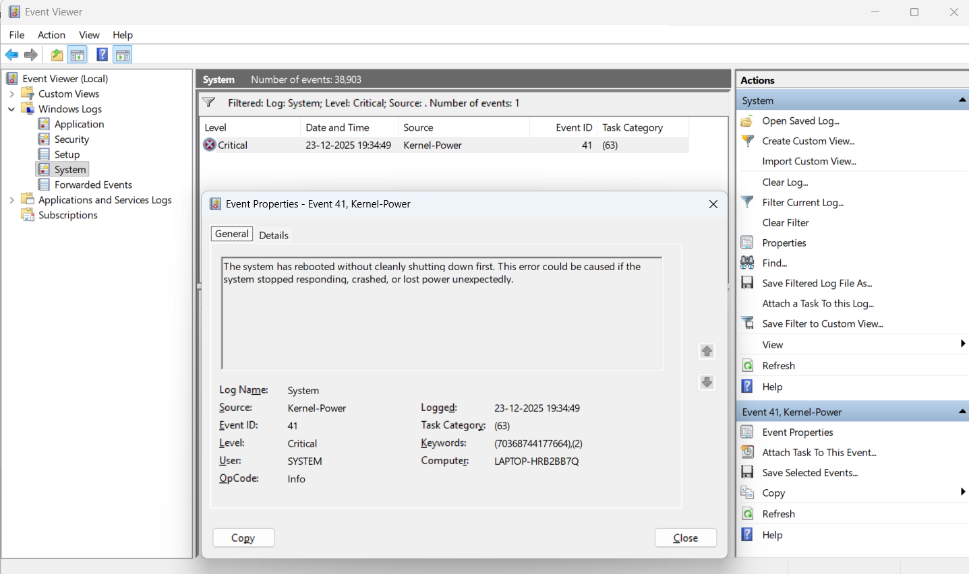
Figure 12: Event Properties showing details of Critical Event ID 41 generated by Kernel-Power.
POC Explanation
The Event Properties window records:
- Log Name: System
- Source: Kernel-Power
- Event ID: 41
- Level: Critical
- Logged: 23-12-2025 19:34:49
- Task Category: (63)
- User: SYSTEM
- Computer: LAPTOP-HRB2BB7Q
Event ID 41 provides evidence of an unexpected system restart without a clean shutdown. The event itself records the unexpected restart but does not establish the exact underlying cause.
Step 4: Record the Event ID and Prepare the Final Observation
The identified critical event is recorded as the final finding from the local Windows System log.
Identified Critical Event:
Event ID | Source | Level | Significance | Logged | User
41 | Kernel-Power | Critical | Indicates that the system rebooted without a clean shutdown. | 23-12-2025 19:34:49 | SYSTEM
The Event Viewer contained one Critical event after filtering the System log for the Critical level.

Observation:
The Windows System Event Log was filtered to identify Critical events. The analysis revealed one Critical event, Event ID 41 generated by Kernel-Power. The event was logged on 23-12-2025 at 19:34:49 and records that the system rebooted without a clean shutdown.

Conclusion:
The practical successfully identified and analyzed a Critical Windows Event ID from the local computer's Event Viewer. Event ID 41 (Kernel-Power) was documented along with its source, severity, timestamp, and significance.

Practical-5 Network Forensics with Wireshark

AIM: “Analyze an instructor-provided PCAP to identify protocols, suspicious traffic patterns, and a defensible event timeline.”

Requirements
- Wireshark
- malicious_pcap_final.pcap
- ftp-capture.pcap

Procedure
Step 1: Open and Analyze the Malicious PCAP File
Open Wireshark.
Go to: File → Open → malicious_pcap_final.pcap
Now look at the Protocol column. You should see different protocols such as:
FTP, HTTP, DNS, TCP, UDP
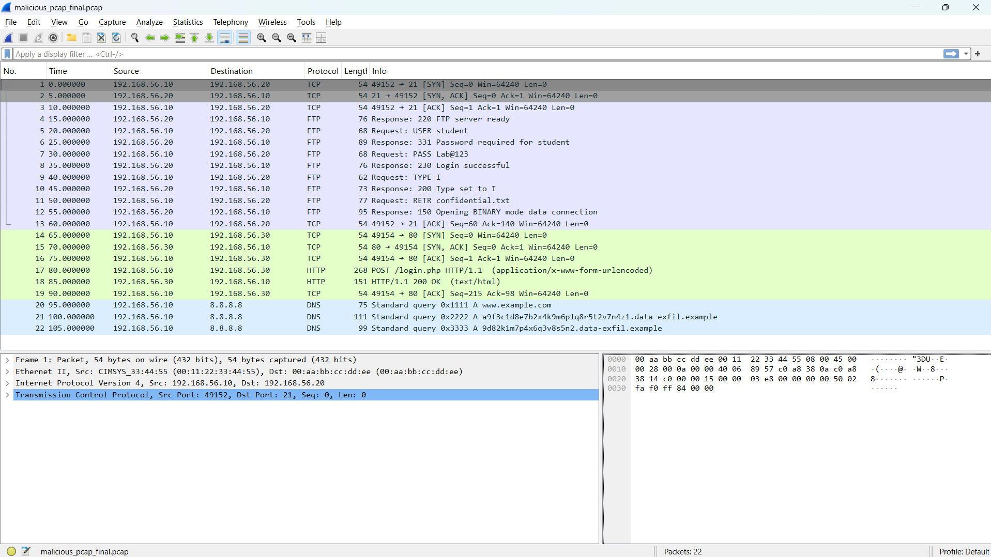
Figure 1: Overview of the malicious PCAP file analyzed using Wireshark
POC Explanation
A PCAP file contains captured network packets. Wireshark allows us to inspect these packets and identify suspicious communication, credentials, and attack activity.

Step 2: Analyze FTP Credentials from ftp-capture.pcap
Now, Open the second PCAP file
File → Open → ftp-capture.pcap
In the Wireshark Display Filter bar, enter: ftp
Press Enter.
Now inspect the Info column and the packet details.
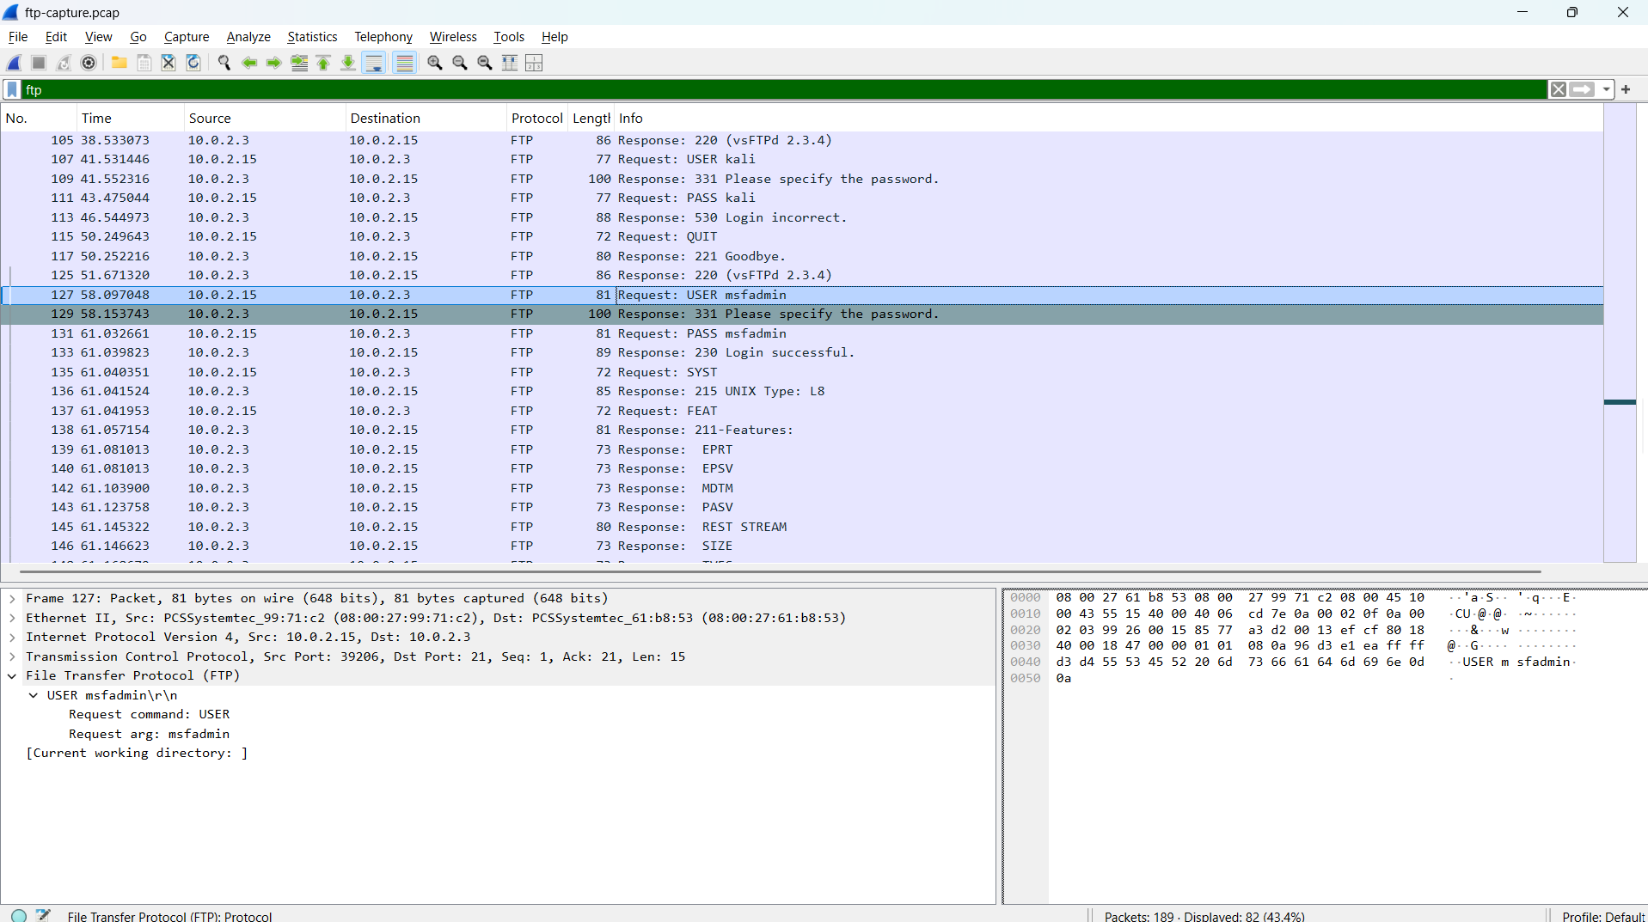
Figure 2: FTP credentials captured in plain text using Wireshark
POC Explanation
The FTP capture contains authentication attempts with credentials transmitted in plain text.
We can observe credentials such as:
Username: msfadmin
Password: msfadmin
The capture also contains an Anonymous FTP login and other unsuccessful login attempts.
FTP does not encrypt its authentication traffic. Therefore, when FTP packets are captured, the USER and PASS commands can be read directly in Wireshark.
This demonstrates that plain FTP can expose login credentials to anyone who is able to capture the network traffic.
Step 3: Analyze FTP File Access / Suspicious Activity
Now return to the first PCAP file:
File → Open → malicious_pcap_final.pcap
Apply the filter: ftp
Inspect the Info column and locate the file-transfer commands.
We can observe commands such as:
TYPE I
RETR confidential.txt
Select the packet containing:
RETR confidential.txt
Then right-click it and select:
Follow → TCP Stream
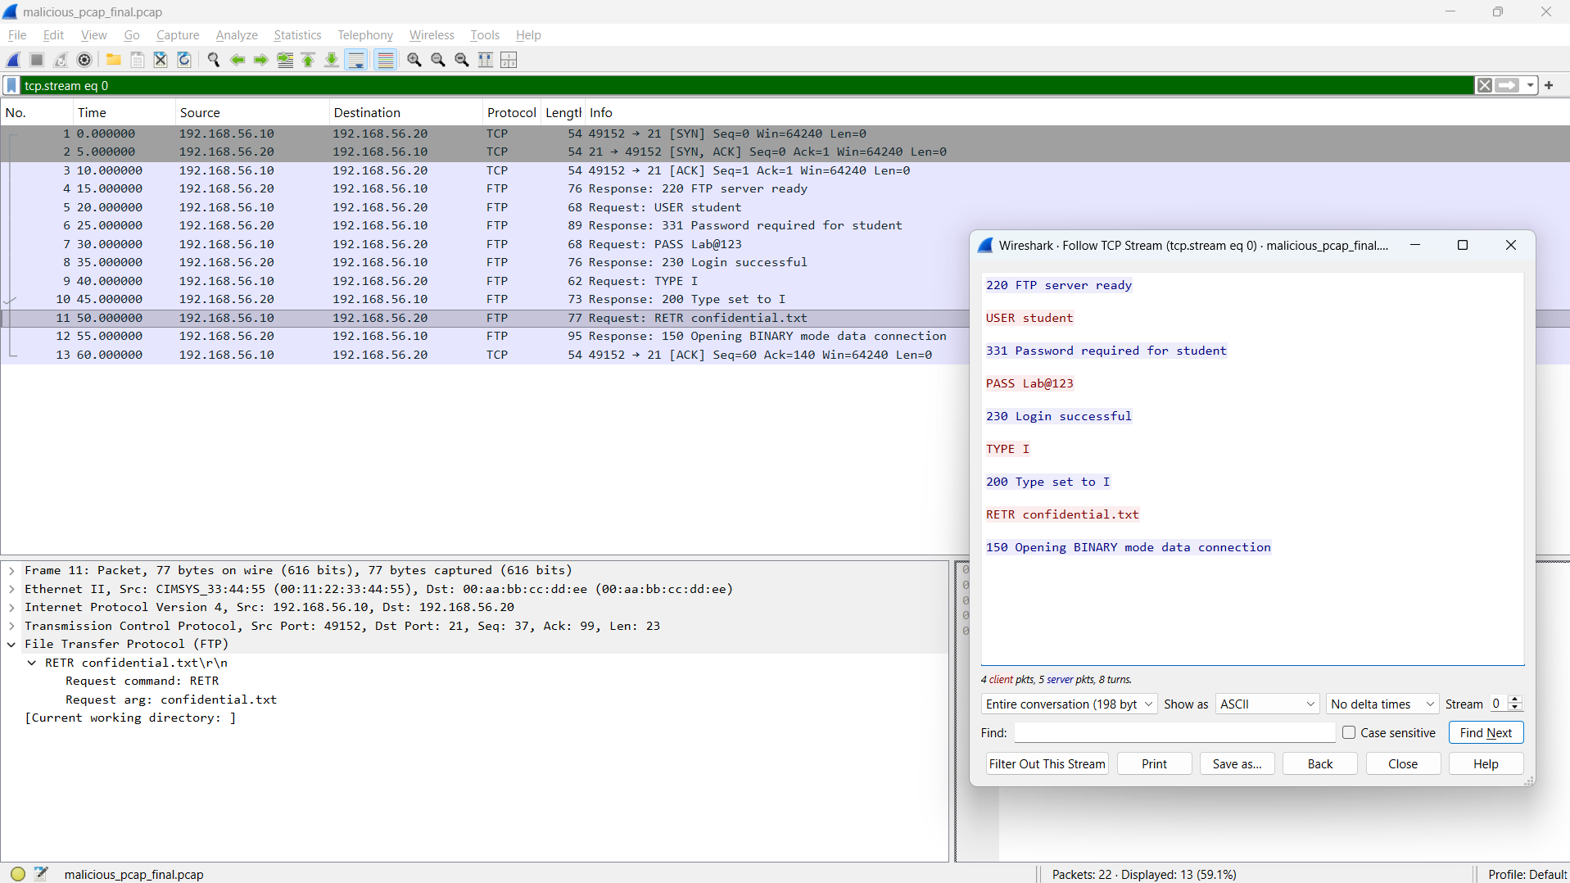
Figure 3: FTP file retrieval activity showing confidential.txt
POC Explanation
The FTP session shows that after authentication, the client requests the file:
RETR confidential.txt
The RETR command is used to retrieve a file from an FTP server. This shows that a file named confidential.txt was accessed during the FTP session.
Step 4: Detect DNS Anomaly / Possible DNS Tunneling & Beaconing
DNS queries were inspected to identify anomalous domain patterns and repeated periodic queries that may indicate DNS tunneling or beaconing-style data exfiltration.
In the Wireshark Display Filter bar, enter: dns
Press Enter.
Now inspect the DNS queries in the Info column.
Look for unusually long or random-looking domain/subdomain names.
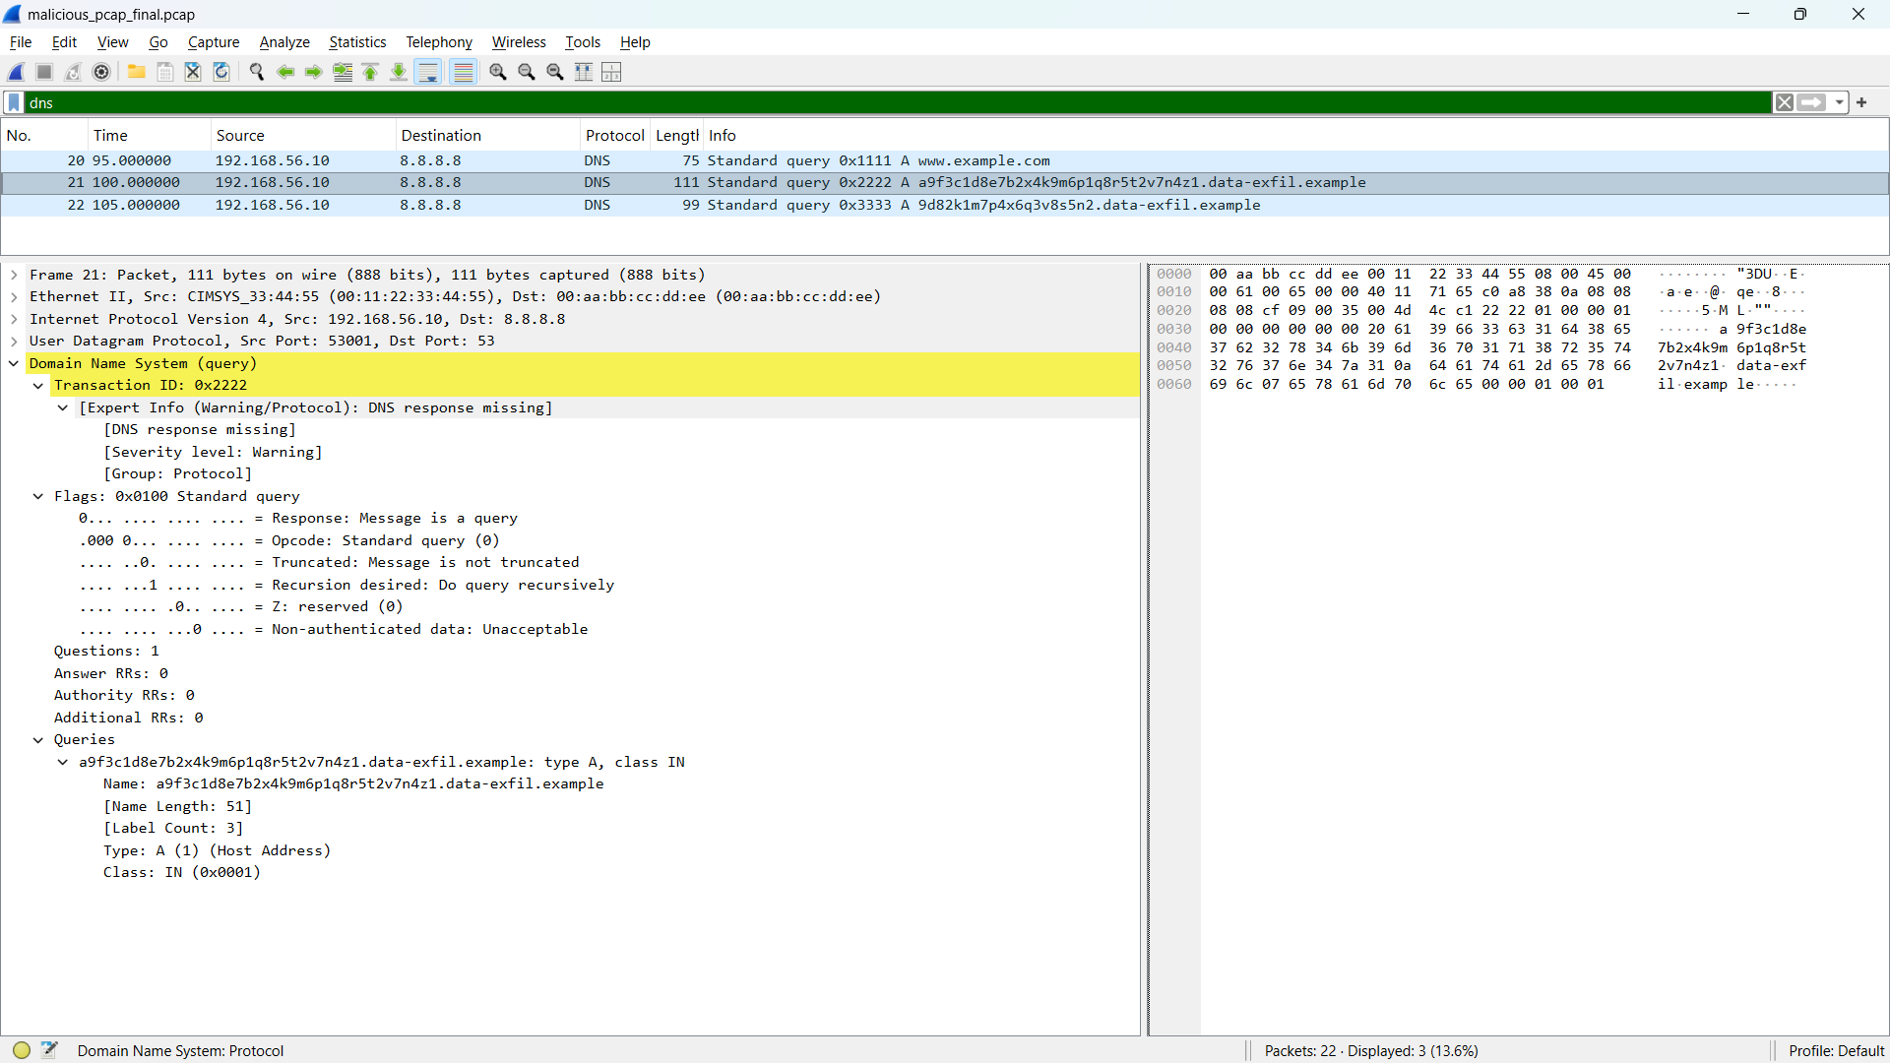
Figure 4: Detection of suspicious, regularly-spaced DNS queries with randomized subdomains indicating possible DNS tunneling and beaconing activity.
POC Explanation
The last two queries contain long, randomly generated subdomain labels under the domain data-exfil.example, which is characteristic of DNS tunneling, where data is encoded and exfiltrated through DNS query names.
The queries also occur in a short, regular sequence to the same resolver, resembling beaconing behavior repeated, low-interval outbound requests typical of an infected host periodically communicating with an external endpoint.
Unlike normal DNS resolution, which targets legitimate, human-readable domains, this repeated pattern of random-subdomain queries to a single suspicious parent domain indicates automated, non-user-initiated traffic consistent with a covert communication or exfiltration channel.
Step 5: Analyze HTTP Credentials
In the Wireshark Display Filter bar, enter: http
Press Enter.
Look for the HTTP request to: POST /login.php
Select the packet and expand Hypertext Transfer Protocol in the Packet Details section.
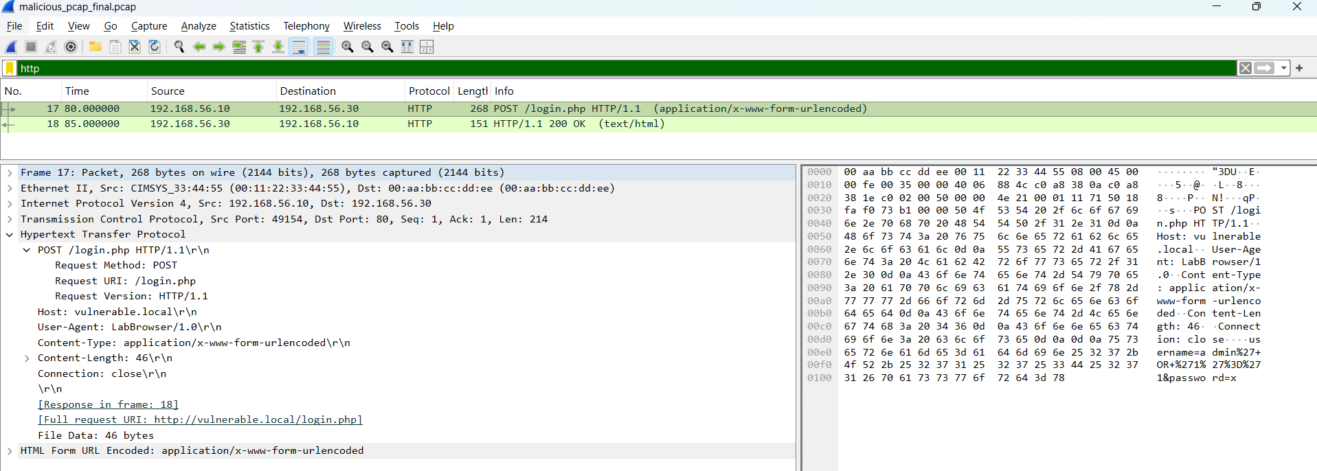
Figure 5: HTTP POST request exposing login credentials and parameters
POC Explanation
The HTTP POST request contains login parameters, including:
username= “admin”
password= “x”
HTTP does not encrypt its contents. Therefore, login information sent through an HTTP POST request can be viewed directly from a packet capture.
This demonstrates the risk of transmitting sensitive credentials over unencrypted HTTP.

Step 6: Identify SQL Injection Payload
Continue analyzing the HTTP POST packet from Step 5.
Look at the username parameter in the HTTP request. The value is URL-encoded as:
admin%27+OR+%271%27%3D%271
This can be decoded as:
admin' OR '1'='1
The suspicious part of the request is: ' OR '1'='1
We can also inspect the corresponding HTTP response and observe:
HTTP/1.1 200 OK
Login accepted
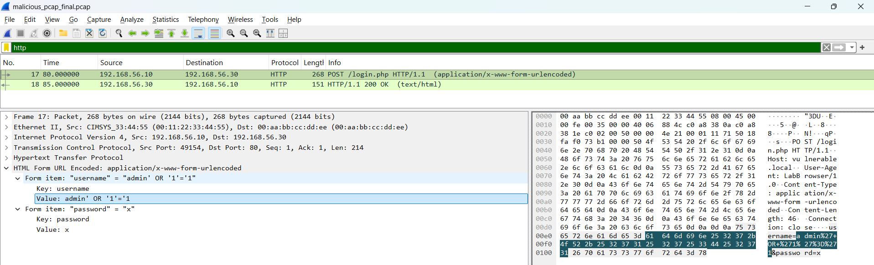
Figure 6: SQL injection payload detected in HTTP request
POC Explanation
The payload attempts to modify the application's SQL authentication condition. Since '1'='1' is always true, this type of input can be used to attempt an SQL Injection authentication bypass.
The successful response makes the activity suspicious and indicates that the vulnerable application accepted the crafted request.

Step 7: Reconstruct the Network Attack Timeline
Now we combine the observations from the previous steps and arrange them in chronological order using the Time, Source, Destination, Protocol, and Info columns in Wireshark.
POC
The observed attack sequence can be summarized as:
- FTP authentication — credentials are transmitted in plain text.
- FTP file access — RETR confidential.txt is used to request a file.
- HTTP login request — POST /login.php contains login parameters.
- SQL Injection — admin' OR '1'='1 is submitted as the username.
- Successful response — the server returns HTTP 200 OK and Login accepted.
- DNS anomaly — unusually long/random DNS queries are observed, indicating possible DNS tunneling or data exfiltration.
A network attack timeline helps us understand the relationship between individual packets and reconstruct the overall sequence of suspicious activities.
Observation:
- FTP credentials were exposed in plain text.
- FTP was used to request confidential.txt.
- HTTP transmitted login information without encryption.
- A SQL injection payload was detected in the HTTP request.
- Suspicious DNS queries containing long/random subdomains were identified, occurring at regular intervals consistent with beaconing behavior.
- The captured activities can be correlated using packet timestamps.

Conclusion:
The malicious PCAP was successfully analyzed using Wireshark. The analysis identified plain-text FTP credentials, suspicious FTP file access, exposed HTTP login data, SQL injection activity, and abnormal, beaconing-like DNS queries indicating possible tunneling. These findings were used to reconstruct the sequence of suspicious network activities.

Practical-6 Email Forensics

AIM: “Analyze a sample email header and identify technical indicators that may suggest spoofing or suspicious routing.”

Procedure
Step 1: Obtain the Email Headers (Own Inbox + Instructor Sample)
Two email headers were collected for comparison, a suspicious sample provided by the sir and a legitimate email retrieved from a personal inbox.
Action
- provided sample header (email-header-sample-1.txt), pre-supplied.
- Own inbox email, Gmail → open the email → 3-dot menu → Show original → raw header copied/exported as .eml.
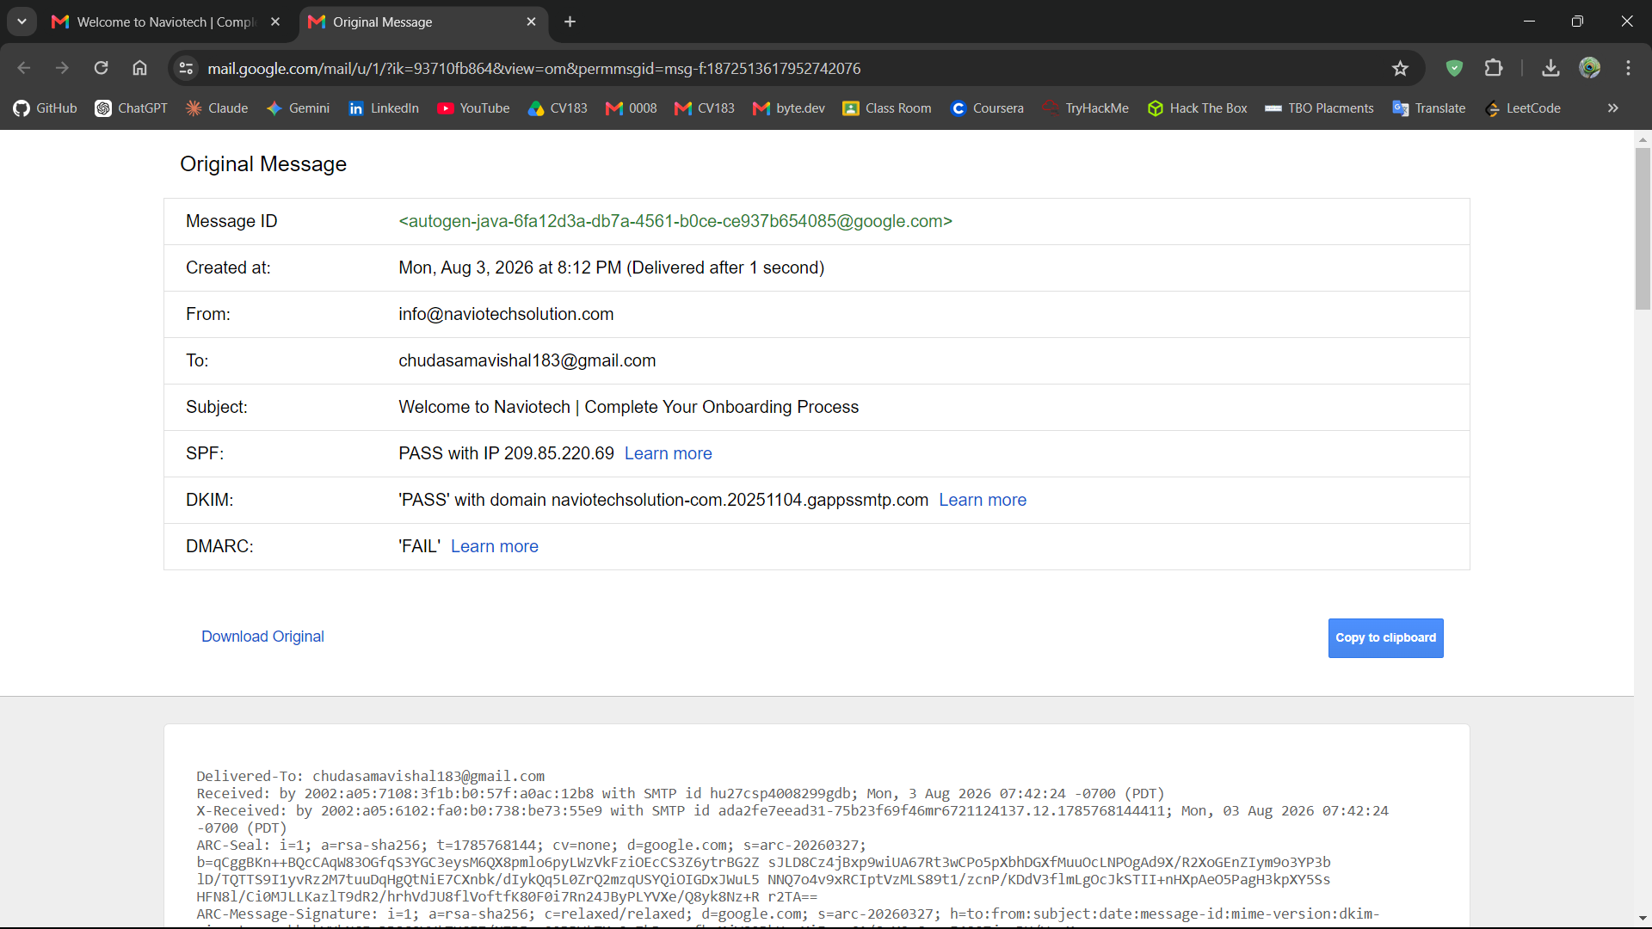
Figure 1: Raw email header obtained from Gmail using the "Show original" option for comparison analysis.

Step 2: Extract Raw Header Source & Parse Using Header Analyzer
The raw header source of both emails was extracted in full and passed through an online header analyzer tool to obtain a structured, hop-by-hop breakdown of the routing and authentication data.
Action
- Copy the complete raw header text of both emails.
- Open MxToolbox Email Header Analyzer: https://mxtoolbox.com/EmailHeaders.asp
- Paste the raw header into the tool and click Analyze Header — repeat separately for the provider-supplied sample and the own-inbox email.
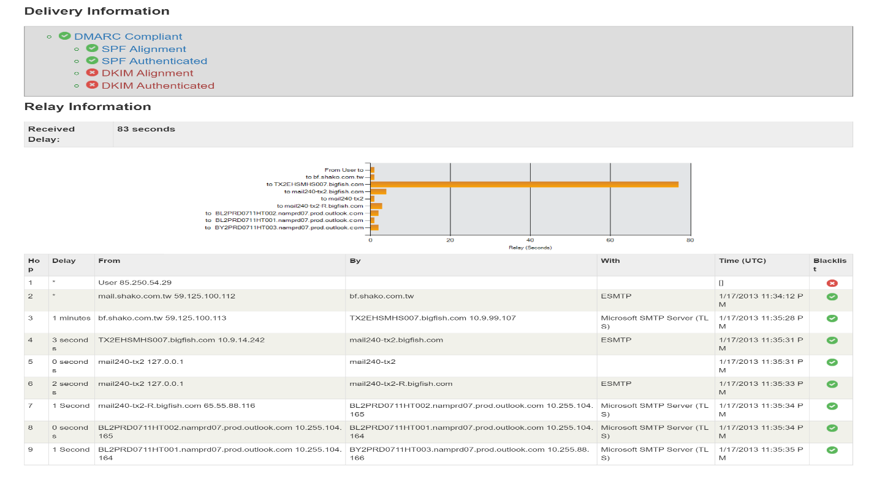
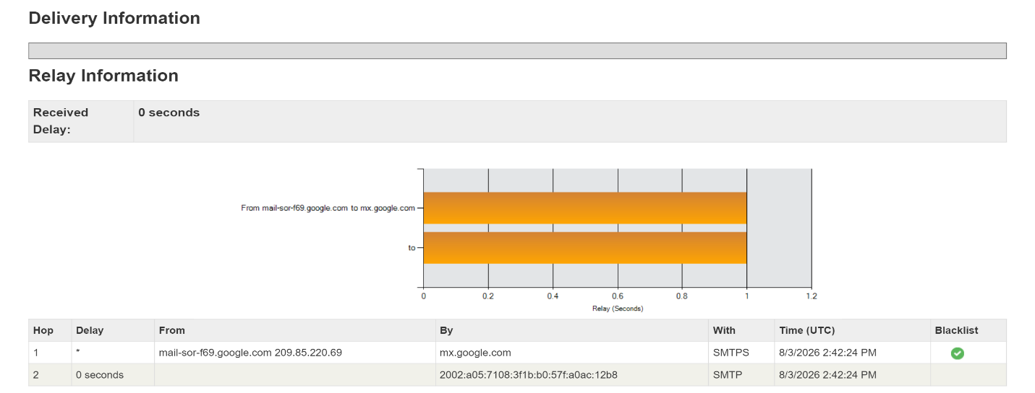
- Review the parsed output: Delivery Summary, Received chain, and Authentication results (SPF/DKIM/DMARC).
Figure 2b: MxToolbox Delivery Information for the provider-supplied sample header showing SPF authenticated but DKIM alignment and authentication failed.
Figure 2a: MxToolbox Authentication-Results for the own inbox email showing both SPF and DKIM passed.
POC Explanation

The own inbox email returns SPF: pass and DKIM: pass, confirming the sending server (209.85.220.69, Google infrastructure) was authorized to send on behalf of naviotechsolution.com and that the message content was not altered in transit. In contrast, the provider-supplied sample shows SPF: Authenticated but DKIM: Not Aligned / Not Authenticated, meaning no valid DKIM signature was present to verify sender identity and message integrity. The absence of DKIM in the sample, combined with its multi-hop relay through an unrelated domain (bf.shako.com.tw), is a strong indicator of a spoofed or unauthenticated sender, reinforcing that the sample email cannot be trusted as genuinely originating from aol.com.

Step 3: Analyze Basic Header Fields (From, To, Date, Message-ID, Return-Path)
The core identity fields of both headers were compared to check for sender/recipient consistency and possible spoofing indicators.
Action
Review the following fields directly from each raw header (or the MxToolbox "Headers Found" table):
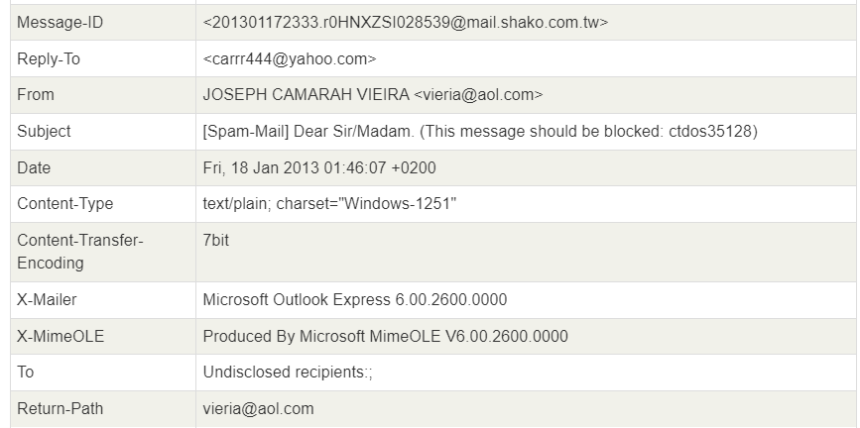
Figure 3: From, Reply-To, and Return-Path field mismatch in the provider-supplied header indicating sender spoofing.
Field | Own Inbox | Provider Sample
From | info@naviotechsolution.com | JOSEPH CAMARAH VIEIRA vieria@aol.com
Reply-To | (not present) | carrr444@yahoo.com
Return-Path | info@naviotechsolution.com | vieria@aol.com
Message-ID | ...@google.com | ...@mail.shako.com.tw
To | chudasamavishal183@gmail.com | Undisclosed recipients:;

POC Explanation
In the own-inbox email, From and Return-Path match exactly (naviotechsolution.com), and the Message-ID domain aligns with the sending infrastructure (Google), indicating a consistent, legitimate sender identity. In the provider sample, the Reply-To (carrr444@yahoo.com) differs from the From address (vieria@aol.com), and neither matches the Message-ID domain (mail.shako.com.tw), which is a classic spoofing red flag, replies are redirected to a different address than the one displayed as sender. The To field being "Undisclosed recipients" further indicates a mass/bulk spam distribution rather than a targeted, personal email.

Step 4: Trace the Received: Header Chain (Hop-by-Hop Path & IP Addresses)
The Received: header chain was traced hop-by-hop to identify the originating IP address and verify the routing path of both emails.
Review the Relay Information table in MxToolbox (Hop, From, By, With, Time columns) for both headers, reading bottom-to-top (the last Received: line = the originating hop, closest to the sender).

Own Inbox (Naviotech):
- Hop 1: mail-sor-f69.google.com (209.85.220.69) → mx.google.com — single hop, direct from Google's mail servers.

Provider Sample:
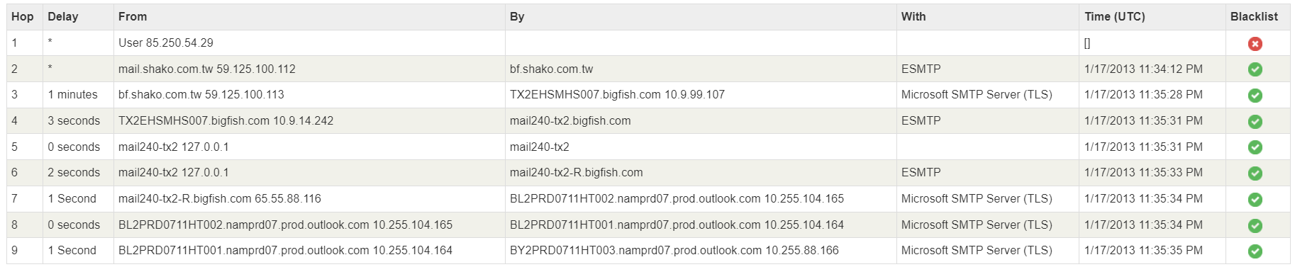
Figure 4: Nine-hop Received header chain for the provider-supplied sample showing IP 85.250.54.29 as the originating source with a falsely claimed hostname.
POC Explanation
The own-inbox email shows a single, direct hop from Google's authenticated mail server to the recipient's mail server, consistent with a legitimate, trusted sending infrastructure. The provider sample, in contrast, shows a 9-hop relay chain originating from IP 85.250.54.29, which falsely claims to be mail.shako.com.tw (per the X-Authentication-Warning header). The message is then relayed through an unrelated spam-filtering service (bigfish.com) before reaching Outlook servers. This long, inconsistent relay path, combined with the originating host falsely identifying itself, is a strong indicator of IP spoofing and an attempt to obscure the true origin of the email.

Step 5: Analyze Authentication Results (SPF / DKIM / DMARC Policy Records)
The actual SPF and DMARC DNS records were examined to determine the sending domain's configured policy, and compared against whether the message actually complied with that policy.
In the MxToolbox result page, review the "SPF and DKIM Information" section, which displays the raw DNS TXT records for the domain along with any DKIM signature errors.

Own Inbox (Naviotech):
- Authentication-Results: dkim=pass header.i=@naviotechsolution-com.20251104.gappssmtp.com; spf=pass ... smtp.mailfrom=info@naviotechsolution.com
Provider Sample (aol.com):
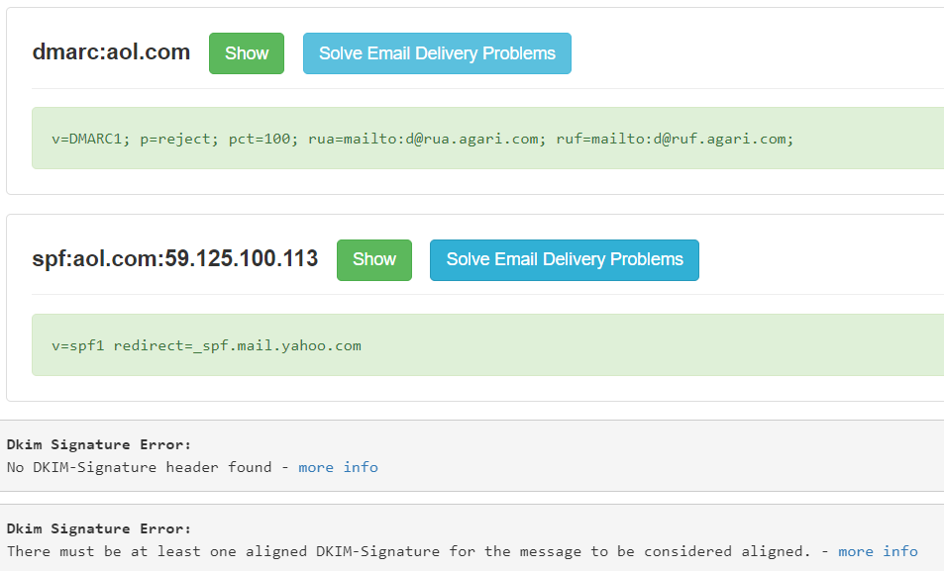
Figure 5: DMARC and SPF DNS records for aol.com alongside DKIM signature errors, showing policy non-compliance in the provider-supplied sample.
POC Explanation
The aol.com domain's own DMARC policy is explicitly set to p=reject, meaning aol.com instructs receiving mail servers to reject any message that fails SPF/DKIM alignment. However, this message has no DKIM signature at all and originates from an IP (59.125.100.113) not authorized under aol.com's SPF chain, meaning it should have been rejected under aol.com's own policy — yet it was still delivered, indicating the receiving server's spam filter (not strict DMARC enforcement) was relied upon to catch it, or that intermediate relays altered enforcement. In contrast, the own-inbox email fully passes both SPF and DKIM under its legitimate sending domain, confirming proper authentication end-to-end. This contrast highlights how a domain can have a strict security policy on paper while spoofed mail still slips through.

Step 6: Compare Both Headers & Identify Red Flags (Spoofing Indicators)
All findings from the previous steps were consolidated into a single comparison to clearly identify the red flags present in the provider-supplied sample.
Tabulate the key indicators from Steps 2–5 side-by-side for both headers to summarize the spoofing evidence.

Indicator | Own Inbox (Legitimate) | Provider Sample (Suspicious)
SPF | Pass | Neutral (not enforced)
DKIM | Pass | Missing (no signature)
DMARC | Compliant | Domain policy `p=reject` violated
From vs Return-Path | Match | Match (`vieria@aol.com`)
From vs Reply-To | N/A (no Reply-To) | Mismatch (`vieria@aol.com` vs `carrr444@yahoo.com`)
Relay Hops | 1 (direct) | 9 (multi-hop, unrelated relay)
Originating Host | Verified Google server | Falsely claimed hostname (`X-Authentication-Warning`)
Spam Score | N/A | 73 (flagged: "This message appears to be spam")
Recipient Field | Specific address | "Undisclosed recipients" (bulk mail)

Conclusion
The email header forensic analysis was successfully performed by comparing a legitimate email header from a personal inbox with a provider-supplied suspicious sample using Wireshark-independent header analysis and the MxToolbox Email Header Analyzer. The analysis revealed clear authentication failures (missing DKIM, unenforced SPF), a sender identity mismatch between the From and Reply-To fields, an abnormally long relay chain with a falsely claimed originating hostname, and a high spam score in the suspicious sample — all of which were absent in the legitimate email. These red flags collectively confirm that email header analysis is an effective forensic technique for detecting spoofed or fraudulent email communications.

Practical-7 Hash Comparison Using PowerShell

AIM: “Calculate and compare hashes of two files using CertUtil and PowerShell to determine whether their contents match.”

Procedure

Step 1: Create the Working Directory and Sample Files
A working directory was created to store two sample files for hash comparison.
- Created a folder named Practical7_HashComparison inside the practical directory.
- Created two text files named Sample1.txt and Sample2.txt.
- Entered identical text in both files and saved them in the working directory.

Step 2: Calculate SHA-256 Hash Using PowerShell
PowerShell was used to calculate the SHA-256 hashes of the two sample files.
- Opened PowerShell in the working directory containing the sample files.
- Executed the following commands:
Get-FileHash ".\Sample1.txt" -Algorithm SHA256
Get-FileHash ".\Sample2.txt" -Algorithm SHA256
- Observed and recorded the hash values displayed for both files.
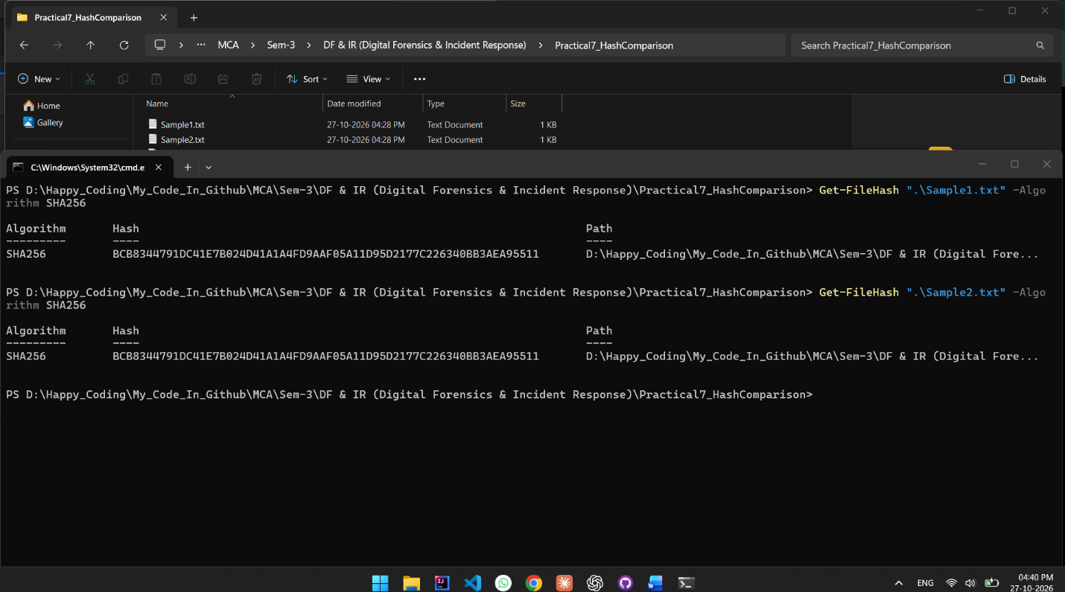
Figure 13: PowerShell displaying the SHA-256 hashes of Sample1.txt and Sample2.txt.
POC Explanation:
PowerShell's Get-FileHash command was used to calculate the SHA-256 hashes of Sample1.txt and Sample2.txt. Both files produced the same hash value, BCB8344791DC41E7B024D41A1A4FD9AAF05A11D95D2177C226340BB3AEA95511. This confirms that both sample files contain identical data.

Step 3: Calculate SHA-256 Hash Using CertUtil
CertUtil was used to calculate the SHA-256 hashes of the same files and verify the results obtained using PowerShell.
- Executed the following commands:
certutil -hashfile ".\Sample1.txt" SHA256
certutil -hashfile ".\Sample2.txt" SHA256
- Compared the resulting hash values with those obtained using PowerShell.
- Verified that both tools produced identical hash values for each file.
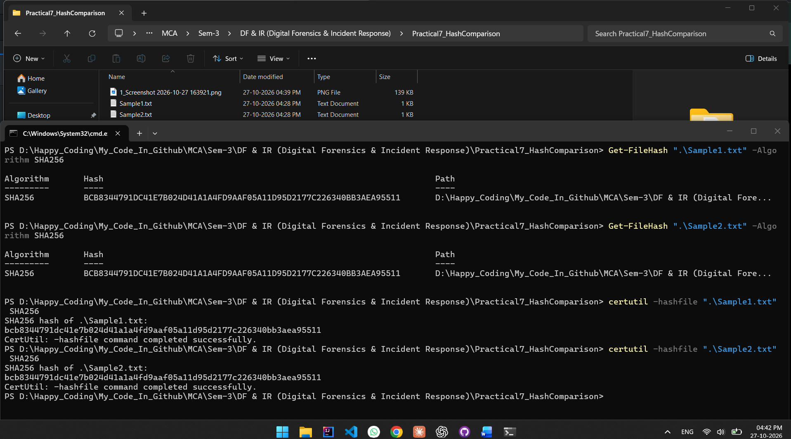
Figure 14: CertUtil displaying the SHA-256 hashes of Sample1.txt and Sample2.txt.
POC Explanation
The certutil -hashfile command was used to calculate the SHA-256 hashes of both sample files. The results matched the values obtained using PowerShell, confirming that both tools generated consistent hash values for the same file contents.

Step 4: Compare Hashes After Copying a File
The first sample file was copied to a separate directory to verify whether copying changed its hash.
- Created a directory named CopyLocation.
- Copied Sample1.txt into the new directory as Sample1_Copy.txt.
- Calculated the SHA-256 hash of the original file:
Get-FileHash ".\Sample1.txt" -Algorithm SHA256
- Calculated the SHA-256 hash of the copied file:
Get-FileHash ".\CopyLocation\Sample1_Copy.txt" -Algorithm SHA256
- Compared both hash values.
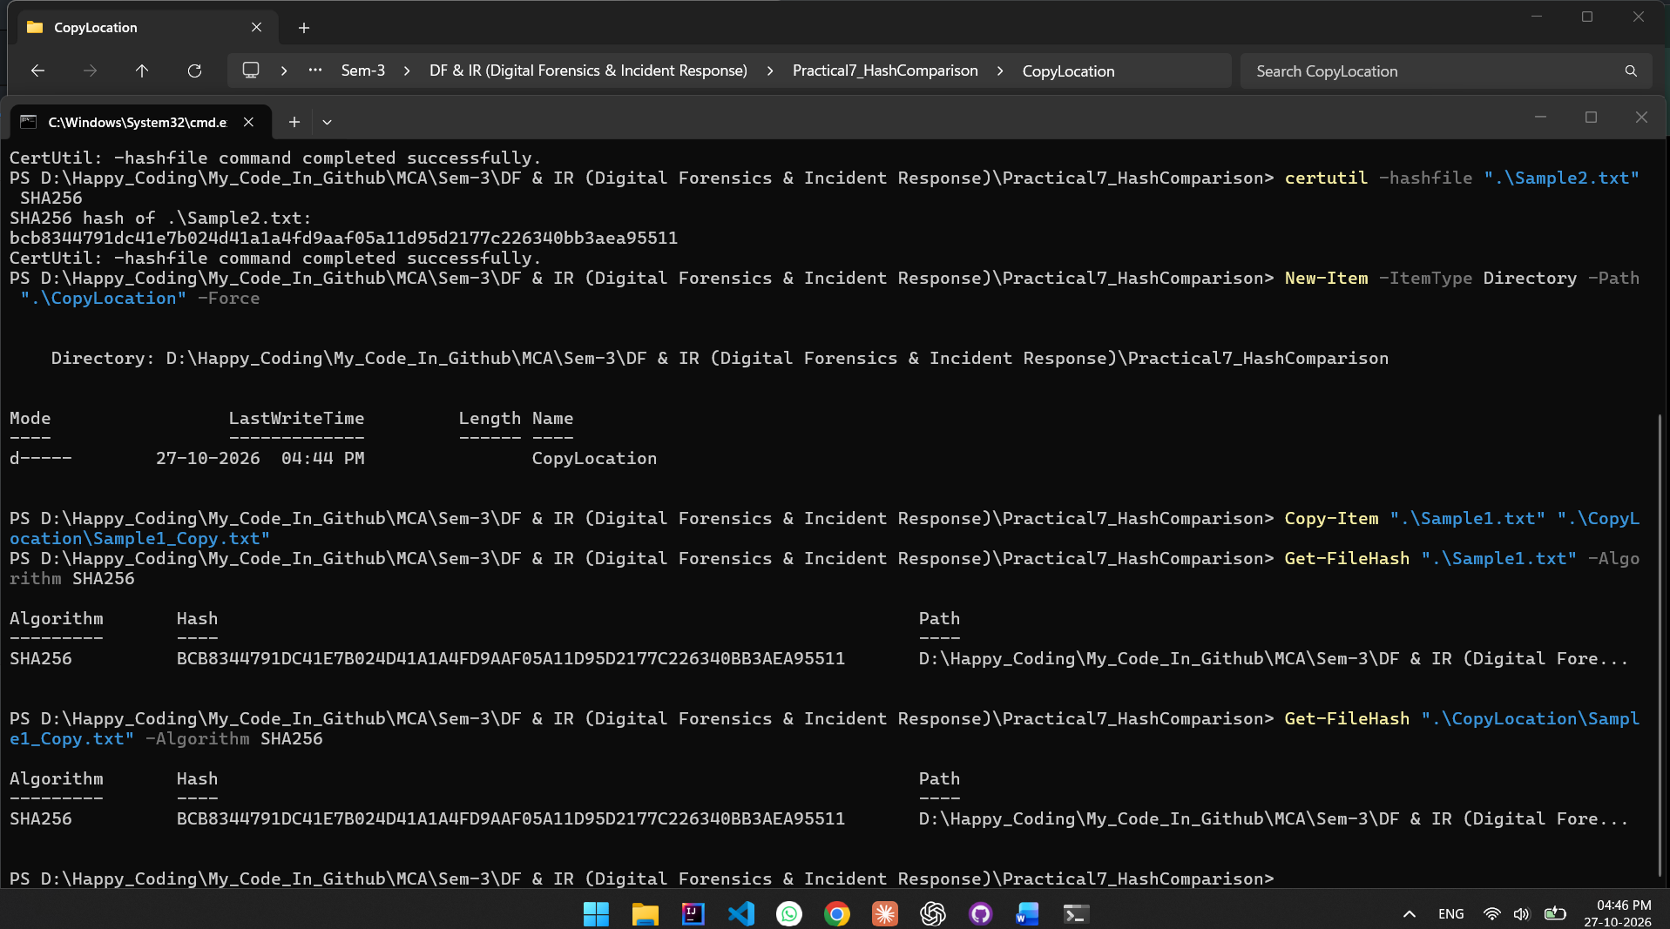
Figure 15: PowerShell displaying the SHA-256 hashes of the original file and its copied version.
POC Explanation
The SHA-256 hashes of the original Sample1.txt and its copied version, Sample1_Copy.txt, were calculated using PowerShell. Both files initially produced the same hash value. This demonstrates that copying a file to another location does not change its hash when the file contents remain unchanged.

Step 5: Compare Hashes After Modifying the Copied File
The copied file was modified to observe the effect of a content change on its SHA-256 hash.
- Appended an additional line to the copied file using the following command:
Add-Content ".\CopyLocation\Sample1_Copy.txt" "This line changes the file content."
- Calculated the SHA-256 hash of the original file:
Get-FileHash ".\Sample1.txt" -Algorithm SHA256
- Calculated the SHA-256 hash of the modified copy:
Get-FileHash ".\CopyLocation\Sample1_Copy.txt" -Algorithm SHA256
- Compared the resulting hash values.
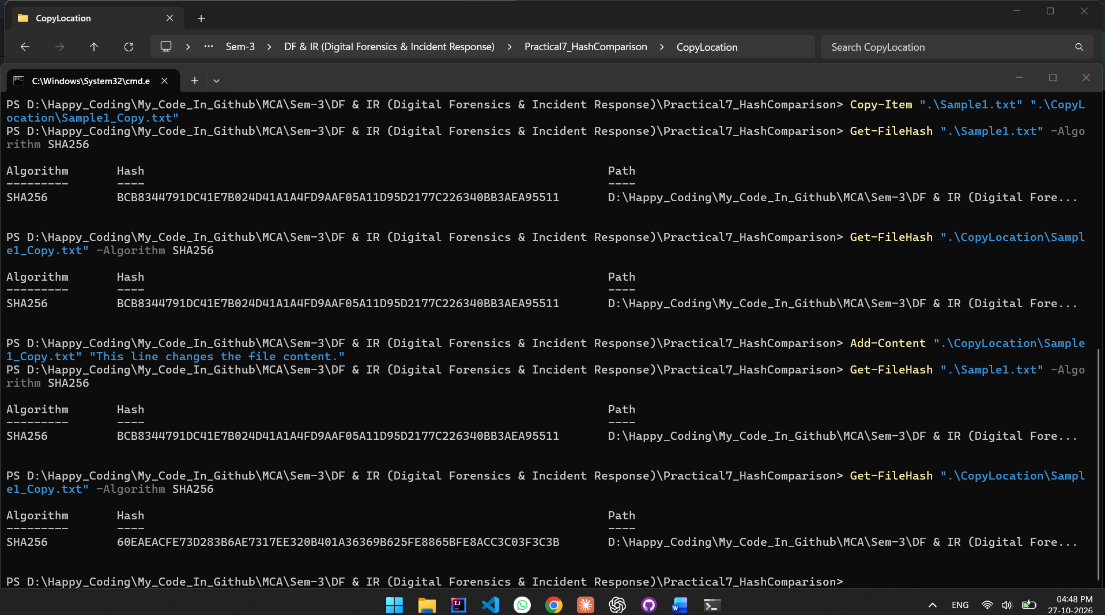
Figure 16: PowerShell displaying different SHA-256 hashes for the original file and the modified copy.
POC Explanation
An additional line was appended to Sample1_Copy.txt, while the original Sample1.txt remained unchanged. The original file retained its SHA-256 hash, whereas the modified copy produced a different hash value. This demonstrates that SHA-256 hash comparison can detect changes in file contents and help verify file integrity.

Observation
- The two sample files produced identical SHA-256 hashes.
- CertUtil and PowerShell produced matching hash values for the same files.
- Copying a file to another directory did not change its hash.
- Modifying the copied file resulted in a different hash, while the original file's hash remained unchanged.

Conclusion
The hash comparison practical was successfully performed using PowerShell and CertUtil. Identical files produced matching SHA-256 hashes, and copying a file did not affect its hash value. After the copied file was modified, its hash changed while the original file's hash remained unchanged. This practical demonstrated how hash comparison can be used to verify file integrity and detect changes in file contents.
Practical-8 USB Device History

AIM: “Identify USB device information recorded on an authorized Windows system using Registry artefacts and USBDeview.”

PROCEDURE
Step 1: Open USBDeview and Record USB Device Information
USBDeview was opened to examine the USB devices recorded on the Windows system. The available details, including device names, descriptions, serial numbers, connection status, drive letters, Vendor IDs, Product IDs, and registry timestamps, were reviewed.
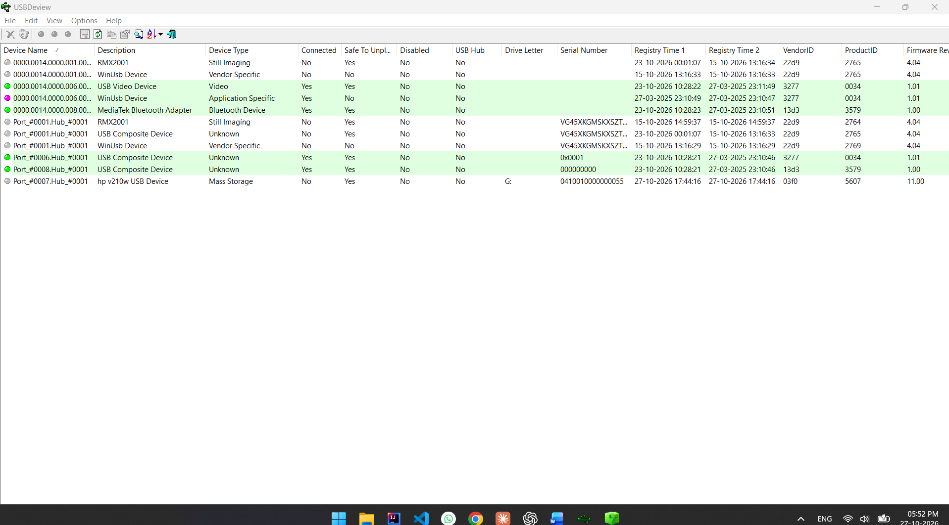
Figure 17: USB Device Inventory Using USBDeview
POC Explanation: This screenshot shows the USB device inventory displayed by USBDeview. It provides information about currently connected and previously recorded devices, including device type, serial number, connection status, Vendor ID, Product ID, and available registry timestamps. The HP v210w USB storage device is visible in the list.

Step 2: Review SYSTEM Hive USBSTOR Artefacts
Registry Explorer was opened, and the Windows SYSTEM registry hive was examined. The following registry artefact was located:
SYSTEM\CurrentControlSet\Enum\USBSTOR
The available device entry and its subkeys were examined to identify the device name, manufacturer, version, serial number, and recorded installation, connection, and removal timestamps.
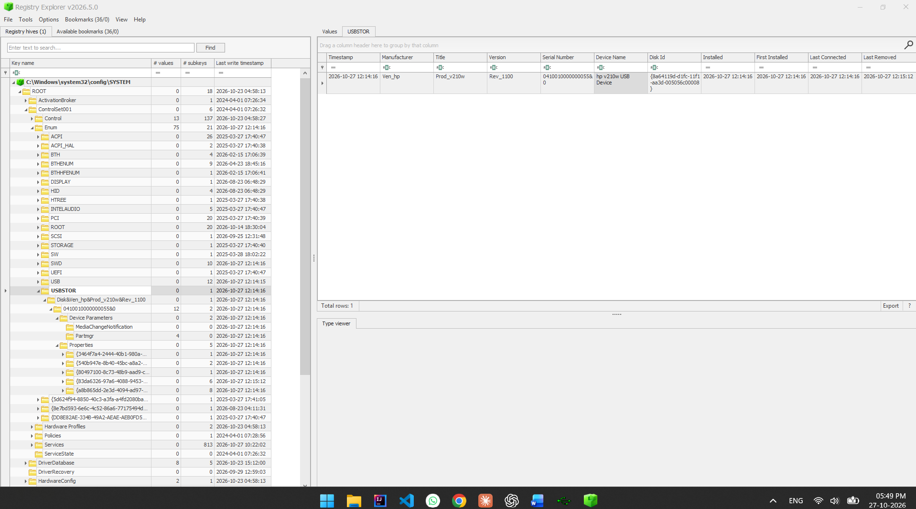
Figure 18: USBSTOR Artefacts in Registry Explorer
POC Explanation: This screenshot shows the USBSTOR artefact in the SYSTEM hive. The record identifies the device as an HP v210w USB device, with manufacturer information displayed as Ven_hp, title Prod_v210w, and version Rev_1100. The screenshot also displays the device instance identifier and available timestamps, which help document the device information recorded by Windows.

Step 3: Compare the Results from Both Sources
The information displayed by USBDeview was compared with the corresponding device record in Registry Explorer. The device name and serial number were used to correlate the entries, while the available identifiers and timestamps were reviewed for differences.
The comparison shows that both tools identify the HP v210w USB storage device. The serial number matches across the two sources. USBDeview also displays Vendor ID 03F0, Product ID 5607, and drive letter G:. Some fields are available in one tool but not the other, and timestamp fields may represent different recorded events.

Step 4: Record the Source and Collection Method
The source and collection method for each finding were documented as follows:
- Source: USBDeview device inventory.
Collection method: The USB device information was viewed and recorded from the USBDeview application.
- Source: Windows SYSTEM registry hive, under SYSTEM\CurrentControlSet\Enum\USBSTOR.
Collection method: The registry artefact was examined using Registry Explorer.
The device name, serial number, available identifiers, and timestamps were recorded for comparison.
The findings were documented with their respective sources and collection methods. This makes the results traceable and helps distinguish information obtained from USBDeview from information obtained from the SYSTEM registry hive.

Step 5: Explain What USB Artefacts Can and Cannot Establish
USB device artefacts can help identify a recorded device, show its available identifiers, and provide recorded installation, connection, or removal information. Comparing multiple sources can help support device identification.
However, these artefacts alone cannot establish which person used the device, prove that files were copied, identify the files transferred, or prove malicious activity.
USB device history is useful for forensic investigation because it provides records associated with USB devices. However, the presence of a device record is not sufficient evidence to conclude that files were transferred or to identify the person responsible.
OBSERVATION
USBDeview and Registry Explorer were used to examine USB device history on the authorized Windows system. Both sources contained information identifying an HP v210w USB storage device, including a matching serial number. USBDeview provided additional details such as Vendor ID, Product ID, drive letter, connection status, and registry timestamps. The comparison demonstrated that different tools may expose different fields and timestamp information.
CONCLUSION
The practical was completed successfully. USB device history was examined using USBDeview and Registry Explorer, and the findings from both sources were compared and documented. The exercise demonstrated how Windows USB artefacts can support device identification and forensic investigation. It also showed that USB presence alone does not prove file transfer or identify the person who used the device.
Practical-9 NTFS MACB Timestamps and USN Journal

AIM: “Inspect NTFS file timestamps and the USN Change Journal to understand file-system activity traces.”

PROCEDURE

Step 1: Select an NTFS Volume and Document Its Source
The D: drive (Hey Programmer) was selected from the authorized Windows lab system. The drive properties were opened through File Explorer to verify the file system type. The properties confirmed that the selected volume uses the NTFS file system.
The test file used for examination was D:\NTFS_Test.txt. It was copied from a pen drive used during the previous practical and renamed for this practical.
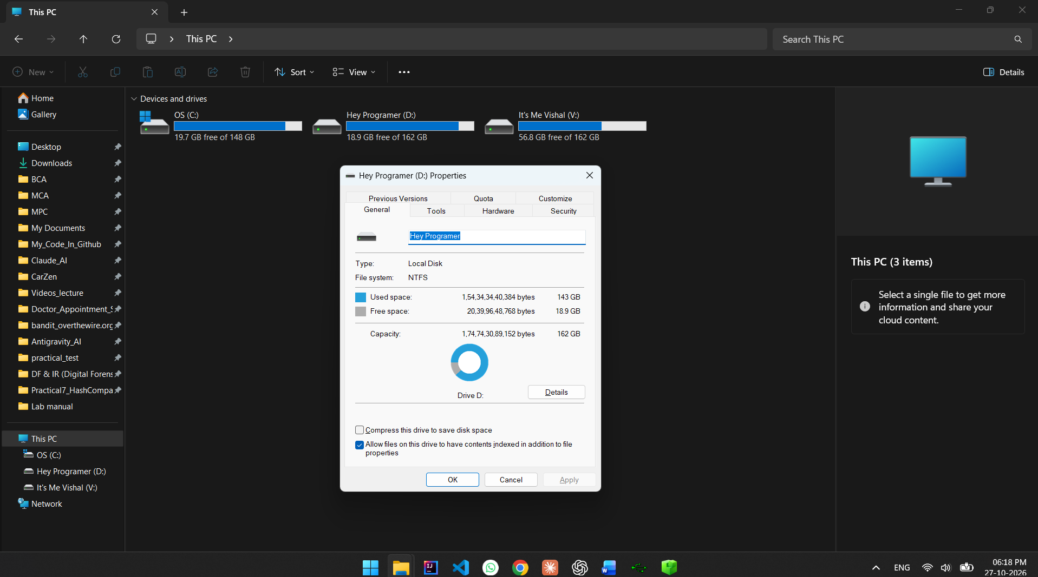
Figure 19: Drive D: Properties Showing the NTFS File System
POC Explanation: This screenshot shows the properties of Drive D:, including its volume label, capacity, used space, free space, and file system. The displayed file system is NTFS, confirming that the selected volume is suitable for examining NTFS timestamps and the USN Change Journal.

Step 2: Identify NTFS MACB Timestamp Fields
The file D:\NTFS_Test.txt was examined through its Properties window and PowerShell. The following PowerShell command was used to display the file path and its available creation, modification, and access timestamps:
Get-Item "D:\NTFS_Test.txt" | Select-Object FullName, CreationTime, LastWriteTime, LastAccessTime
The command displayed the following results:
Timestamp field | Recorded value
Birth / Created | 27-10-2026 17:45:02
Modified | 23-08-2026 21:24:07
Accessed | 27-10-2026 18:24:34
MFT Changed | Not obtained using this command
The file's creation time was later than its modification time. This can occur when a file is copied from another location while retaining its previous modification timestamp.
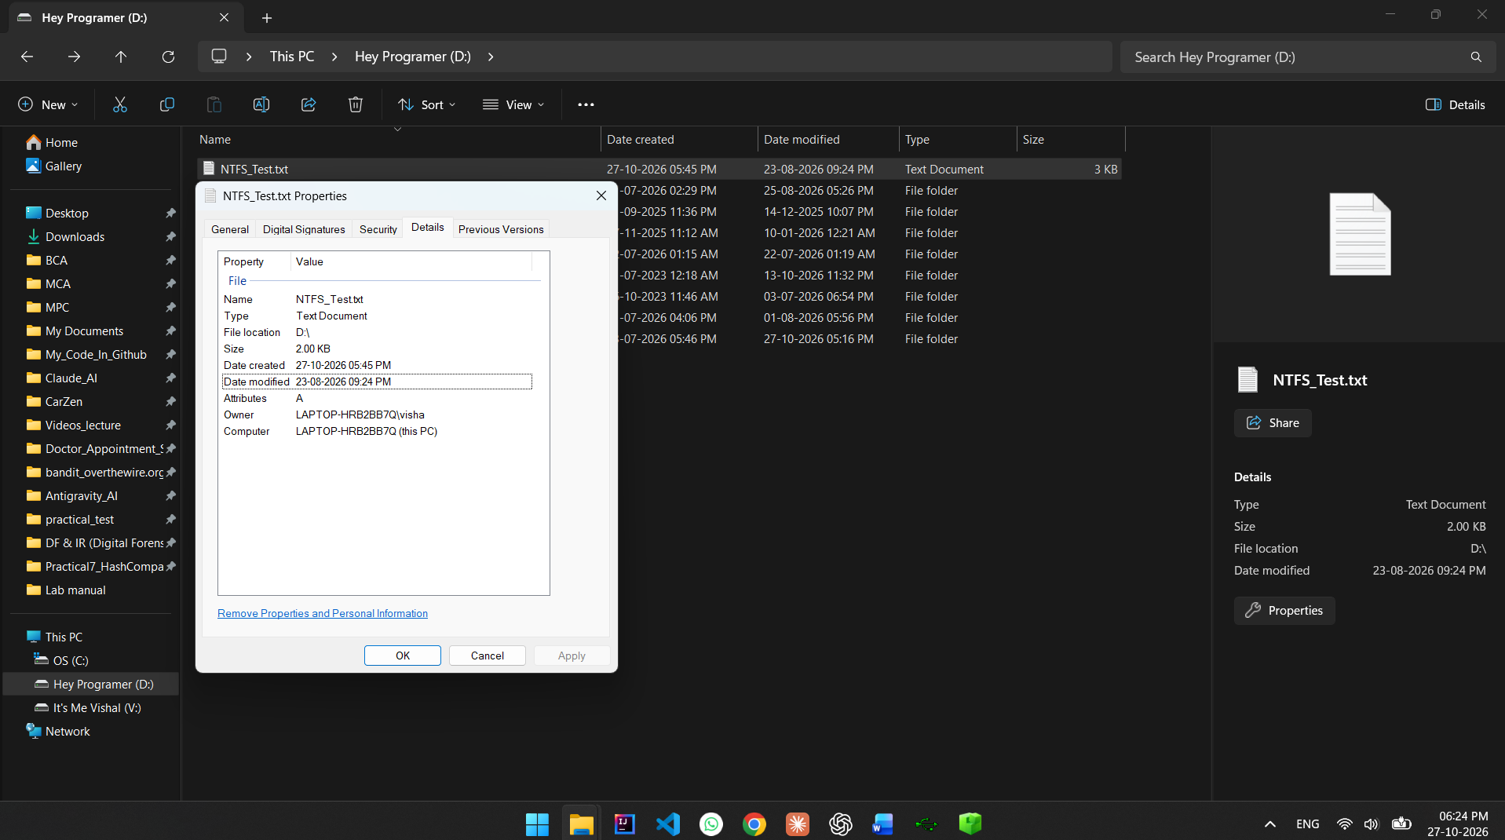
Figure 20: Properties of NTFS_Test.txt
POC Explanation: This screenshot displays the file's properties, including its name, location, creation date, and modification date. It provides preliminary information about the file's timestamps, although the Properties window does not display all four MACB timestamp fields.
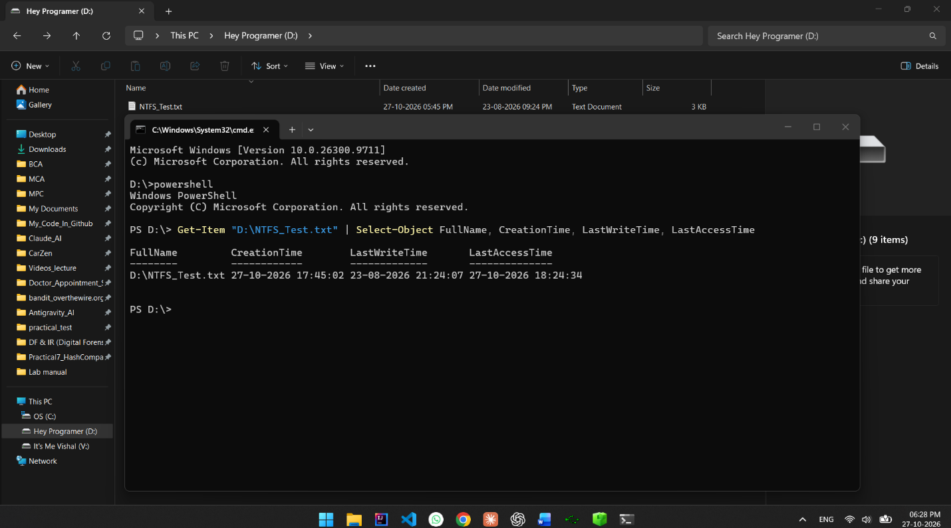
Figure 21: PowerShell Output Showing File Timestamps
POC Explanation: This screenshot shows the output of the Get-Item command. It displays the full file path and the CreationTime, LastWriteTime, and LastAccessTime values. The command provides three useful timestamp fields but does not independently provide the MFT Changed timestamp.

Step 3: Record the Timezone and Timestamp Format
The timestamps displayed by Windows and PowerShell were recorded in the date-time format DD-MM-YYYY HH:MM:SS. The screenshots displayed the local Windows time, including the 24-hour time values in PowerShell.
The fsutil usn queryjournal D: command was used to inspect the USN Change Journal on Drive D:. The output displayed the Journal ID, First USN, Next USN, maximum journal size, allocation delta, and supported record versions.
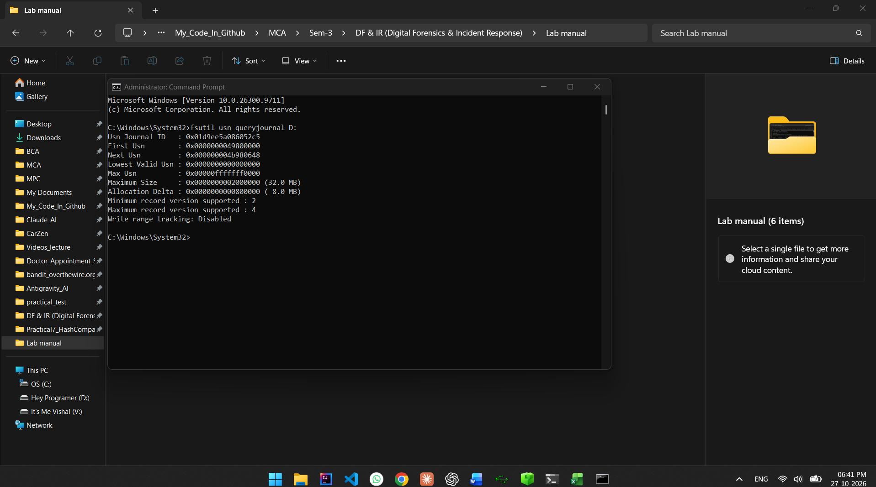
Figure 22: USN Change Journal Information
POC Explanation: This screenshot shows the output of the fsutil usn queryjournal D: command executed in an elevated Command Prompt. It confirms that a USN Change Journal is available on Drive D:. The output also provides the journal's identifying information, USN range, size limits, and supported record versions.

Step 4: Review USN Journal Records
The following command was used to export the USN Journal records from Drive D: into a CSV file:
fsutil usn readjournal D: csv > "%USERPROFILE%\Desktop\Practical9_USN.csv"
The resulting Practical9_USN.csv file was opened in Excel. The records containing NTFS_Test.txt and its earlier filename were examined. The visible entries included rename-related events and Object ID change events.
The following examples were observed in the CSV output:
Filename | USN | Reason flag | Recorded time
NTFS_Test.txt.txt | 1268240696 | Rename: new name | 27-10-2026 18:22
NTFS_Test.txt.txt | 1268240792 | Rename: new name | Close | 27-10-2026 18:22
NTFS_Test.txt | 1268242128 | Rename: new name | 27-10-2026 18:24
NTFS_Test.txt | 1268242116 | Rename: new name | 27-10-2026 18:24
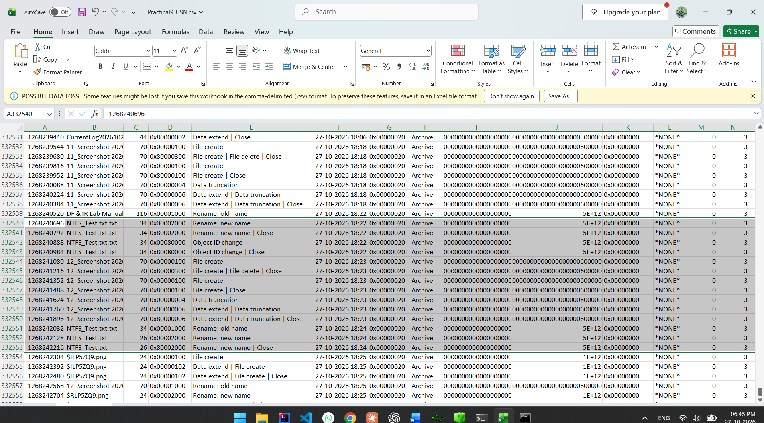
Figure 23: USN Journal CSV Records in Excel
POC Explanation: This screenshot shows the exported USN Journal records in Excel. Entries associated with the test file and its previous filename are visible, including rename-related reason flags and timestamps. These records demonstrate that the journal maintains information about file-system changes. The column headings should be consulted when interpreting each field.

Step 5: Correlate Journal Records with File Metadata
The timestamps obtained through PowerShell were compared with the records visible in the USN Journal. The file's recorded creation, modification, and access times were considered alongside the journal entries associated with its filename changes.
The records show rename-related activity involving NTFS_Test.txt.txt and NTFS_Test.txt. The observations are consistent with the filename being changed during the practical. However, the USN Journal entries alone do not establish the identity of the person who performed the operation or the reason for it.
The comparison demonstrates how ordinary file metadata and USN Journal records can provide complementary information about file-system activity. File timestamps describe recorded metadata times, while USN Journal records describe changes recorded by NTFS. Their correlation helps explain activity traces, but differences in timestamp meanings and available fields must be considered.

OBSERVATION
The D: drive was confirmed to use NTFS. The file D:\NTFS_Test.txt was examined using Windows File Properties and PowerShell, which provided creation, modification, and access timestamps. The USN Change Journal was queried, and its records were exported to CSV for examination.
The journal output contained rename-related entries associated with the test file's earlier and current filenames. The results demonstrate that NTFS metadata and the USN Change Journal can provide useful evidence of file-system activity. The MFT Changed timestamp was not independently obtained during this procedure.

CONCLUSION
The practical was completed successfully. NTFS file timestamps were examined using Windows tools, and the USN Change Journal was queried and reviewed using command-line utilities and Excel. The file metadata and journal records were correlated to understand recorded file-system activity.
The practical demonstrated that MACB timestamps and USN Journal records are useful forensic artefacts. However, timestamp behaviour depends on system operations and settings, and these records alone cannot prove user intent or identify the person responsible for an action.

Practical-10 RAM Acquisition and Memory Forensics

AIM: “Capture volatile memory from an authorized lab machine and examine the memory image using Volatility 3 or a compatible interface.”
To acquire a Windows RAM image and perform memory forensics using Volatility 3 to examine running processes, process relationships, and network connection artefacts.

Procedure
Step 1: Capture RAM Using Magnet RAM Capture
Magnet RAM Capture v1.2.0 was used to acquire a snapshot of the system's volatile memory. RAM acquisition preserves information about the running system that may be lost when the computer is shut down.
- Open Magnet RAM Capture v1.2.0.
- Select the destination folder for saving the memory image.
- Specify the output filename as ramdump.raw.
- Start the RAM capture and wait for the acquisition to finish.
- Verify that the application displays a successful completion message and that the .raw file is created.
Output file: ramdump.raw
Capture size: Approximately 10,232 MB, as displayed by Magnet RAM Capture.
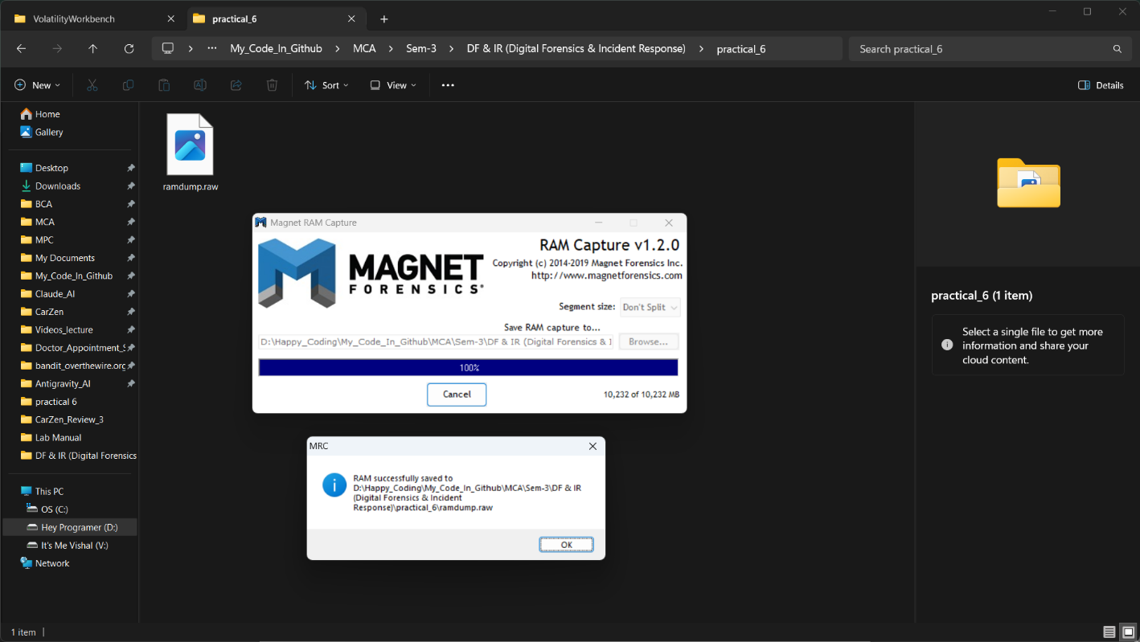
Figure 1: Successful RAM acquisition using Magnet RAM Capture v1.2.0, showing 100% completion and the saved ramdump.raw file.
POC Explanation:
The successful completion of Magnet RAM Capture confirms that the system's volatile memory was acquired and saved as ramdump.raw. The captured memory image, approximately 10,232 MB in size, was used as the input for further analysis with Volatility 3. Preserving RAM allows investigators to examine running processes and other memory artefacts that may be lost when the system shuts down.

Step 2: Load the Memory Image and Examine Running Processes
PassMark Volatility Workbench 3.0 (Build 1017), using Volatility 3 Framework 2.28.2, was used to examine the acquired memory image.
- Open Volatility Workbench.
- Load the captured ramdump.raw memory image.
- Select the Windows platform.
- Run the process-list command to enumerate processes recovered from the memory image.
- Examine the output, including process IDs, parent process IDs, process names, creation times, and other available details.
The process enumeration displayed Windows processes such as System, Registry, smss.exe, csrss.exe, wininit.exe, services.exe, and svchost.exe.
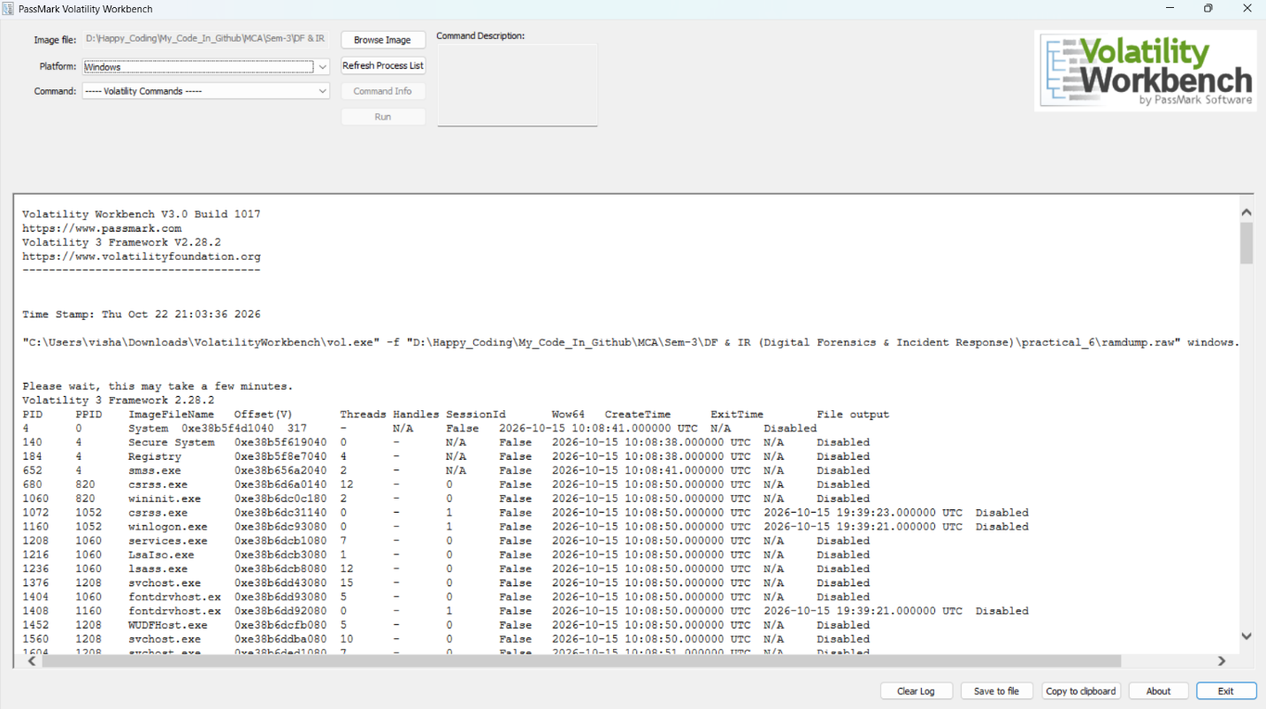
Figure 2: Initial Windows process enumeration from ramdump.raw using Volatility Workbench.
POC Explanation:
The process-list output demonstrates that Volatility 3 can recover process-related information from a Windows memory image. Process names and associated metadata help an examiner understand which applications and operating-system components were present when memory was captured. This information provides a starting point for investigating unusual processes and their relationships.

Step 3: Analyse the Windows Process Tree
The windows.pstree.PsTree plugin was executed to display processes in a hierarchical structure based on their parent process IDs.
- Open the Command dropdown in Volatility Workbench.
- Select windows.pstree.PsTree.
- Leave the Display physical offsets option unchecked.
- Leave the Process ID filter unchecked to display the available process tree.
- Click Run and examine the process hierarchy.
The process-tree output displayed Windows processes including System, smss.exe, csrss.exe, wininit.exe, services.exe, svchost.exe, winlogon.exe, and taskhostw.exe. The output also included WMIRegistration and child processes named mofcomp.exe.
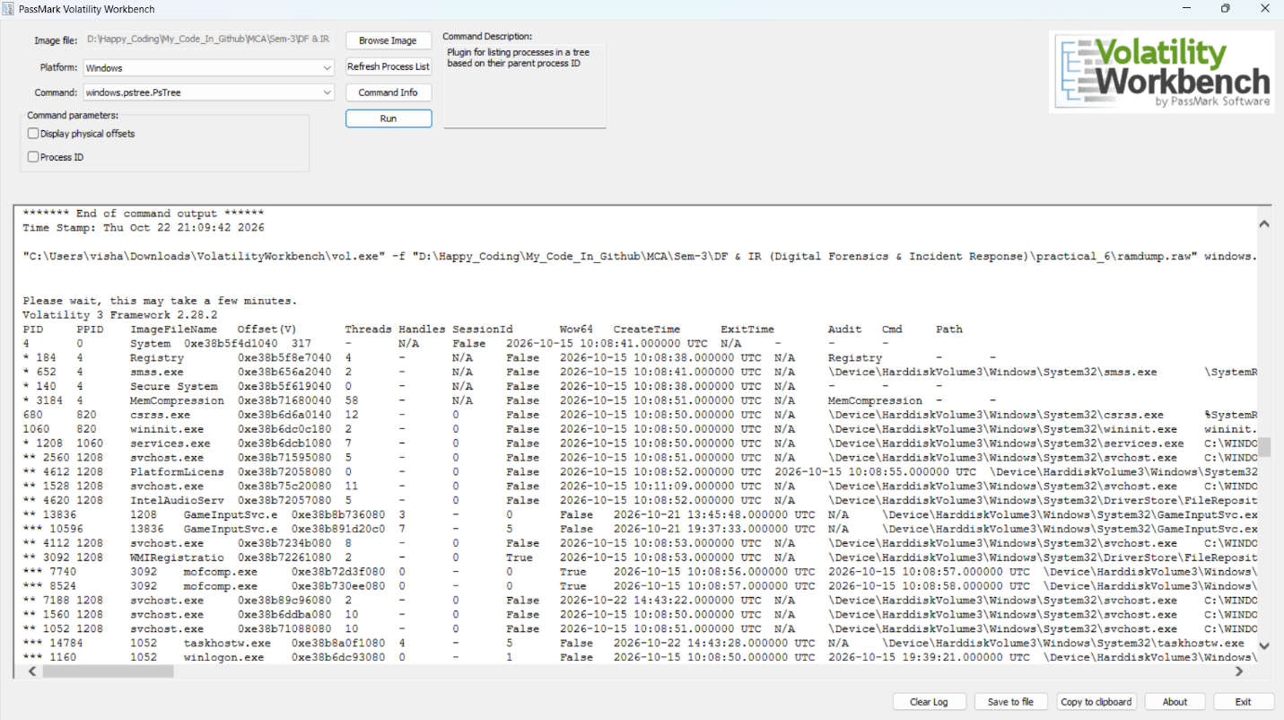
Figure 3: Windows process hierarchy generated using the Volatility 3 windows.pstree.PsTree plugin.
POC Explanation:
A process tree helps an examiner understand the parent-child relationships between processes. Unexpected parent-child relationships, unusual executable paths, and processes running from suspicious locations can provide leads for further investigation.
The appearance of mofcomp.exe in the process tree is an observation that may warrant additional context. However, its presence alone does not establish malicious activity. Process names, parent processes, executable paths, timestamps, and supporting evidence should be considered together before drawing conclusions.

Step 4: Examine Network Connection Artefacts
The windows.netscan.NetScan plugin was executed to search the memory image for recoverable network objects and connection information.
- Open the Command dropdown in Volatility Workbench.
- Select windows.netscan.NetScan.
- Leave the optional Include Corrupt parameter unchecked.
- Click Run and wait for the analysis to finish.
- Examine the output table for network details, including protocol, local address and port, foreign address and port, connection state, PID, and owner.
Result:
The plugin completed its execution, but the final network results table contained no connection entries.
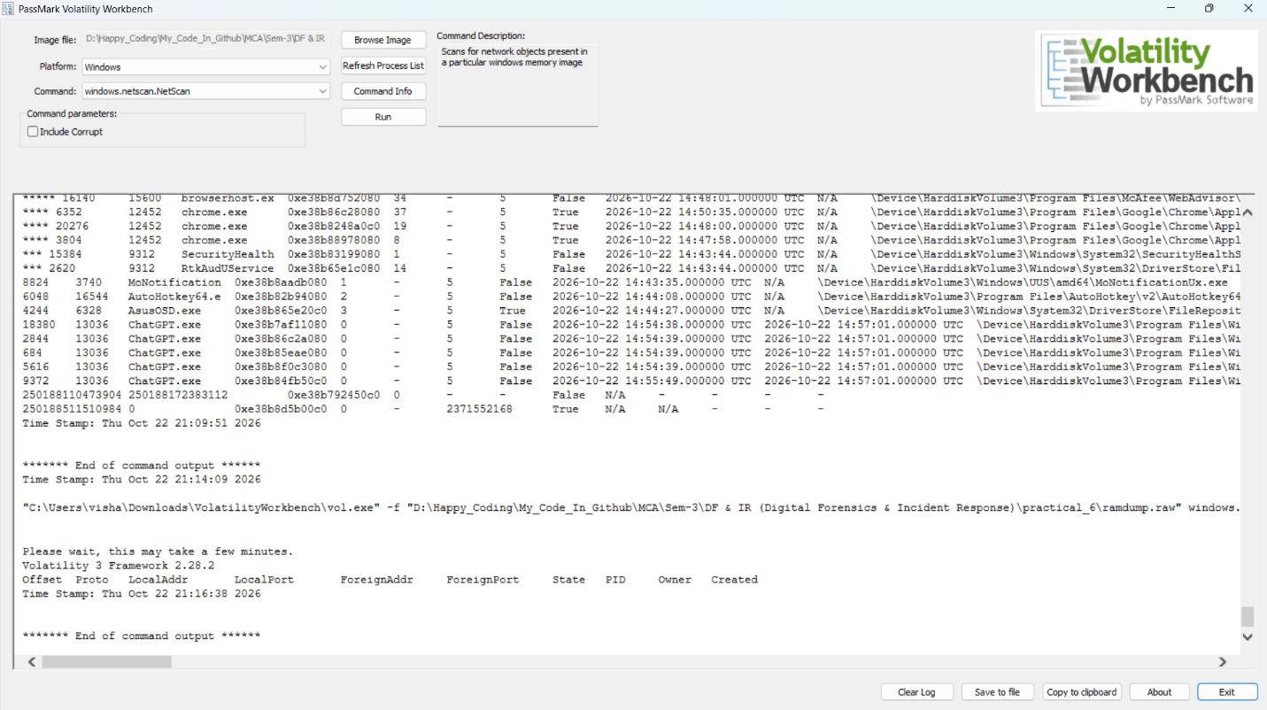
Figure 4: Volatility 3 windows.netscan.NetScan output showing an empty network results table for the analysed memory image.
POC Explanation:
The windows.netscan.NetScan plugin searches a Windows memory image for network objects that can be recovered by the analysis framework. When connection entries are recovered, their addresses, ports, states, and associated process information can help an examiner investigate network activity.
In this analysis, no network connection entries were displayed in the final results table. This means that the scan did not recover any entries for presentation. It does not, by itself, prove that the system had no network activity.

Step 5: Analyze Windows Processes Using PsList
The windows.pslist.PsList plugin in Volatility Workbench was used to examine the processes present in the captured memory image.
- Select the windows.pslist.PsList command in Volatility Workbench.
- Click Run to display the process list.
- Examine the process names, process IDs (PID), parent process IDs (PPID), and other available details.
- Identify the mofcomp.exe processes in the results.
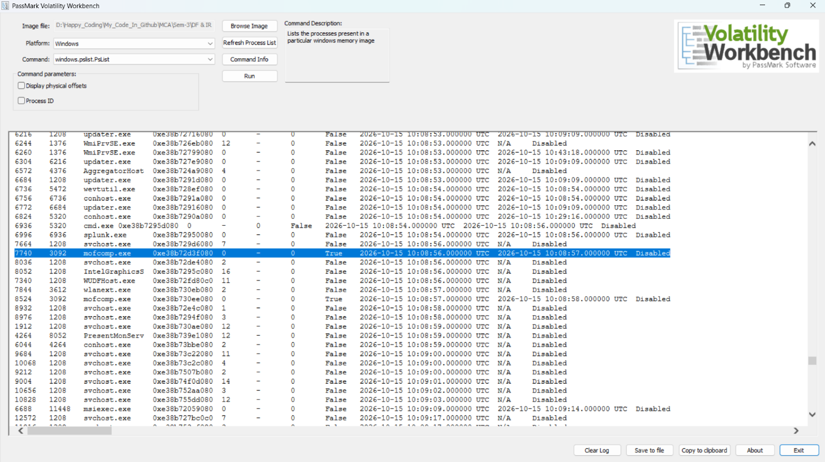
Figure 5: Volatility Workbench displaying the Windows process list, including mofcomp.exe and its associated process information.
POC Explanation
The windows.pslist.PsList plugin lists processes identified in the memory image. Process details, including PID and PPID, help investigators examine process relationships and identify entries that may require further investigation.

Step 6: Extract and Analyze Memory Strings
The Sysinternals Strings utility was used to extract readable text from the captured memory image (ramdump.raw) and save the output in memory_strings.txt.
- Open PowerShell in the directory containing ramdump.raw.
- Run the Strings utility to extract readable strings from the memory dump.
- Save the output to memory_strings.txt.
- Search the extracted text for process names, URLs, and potentially suspicious indicators.
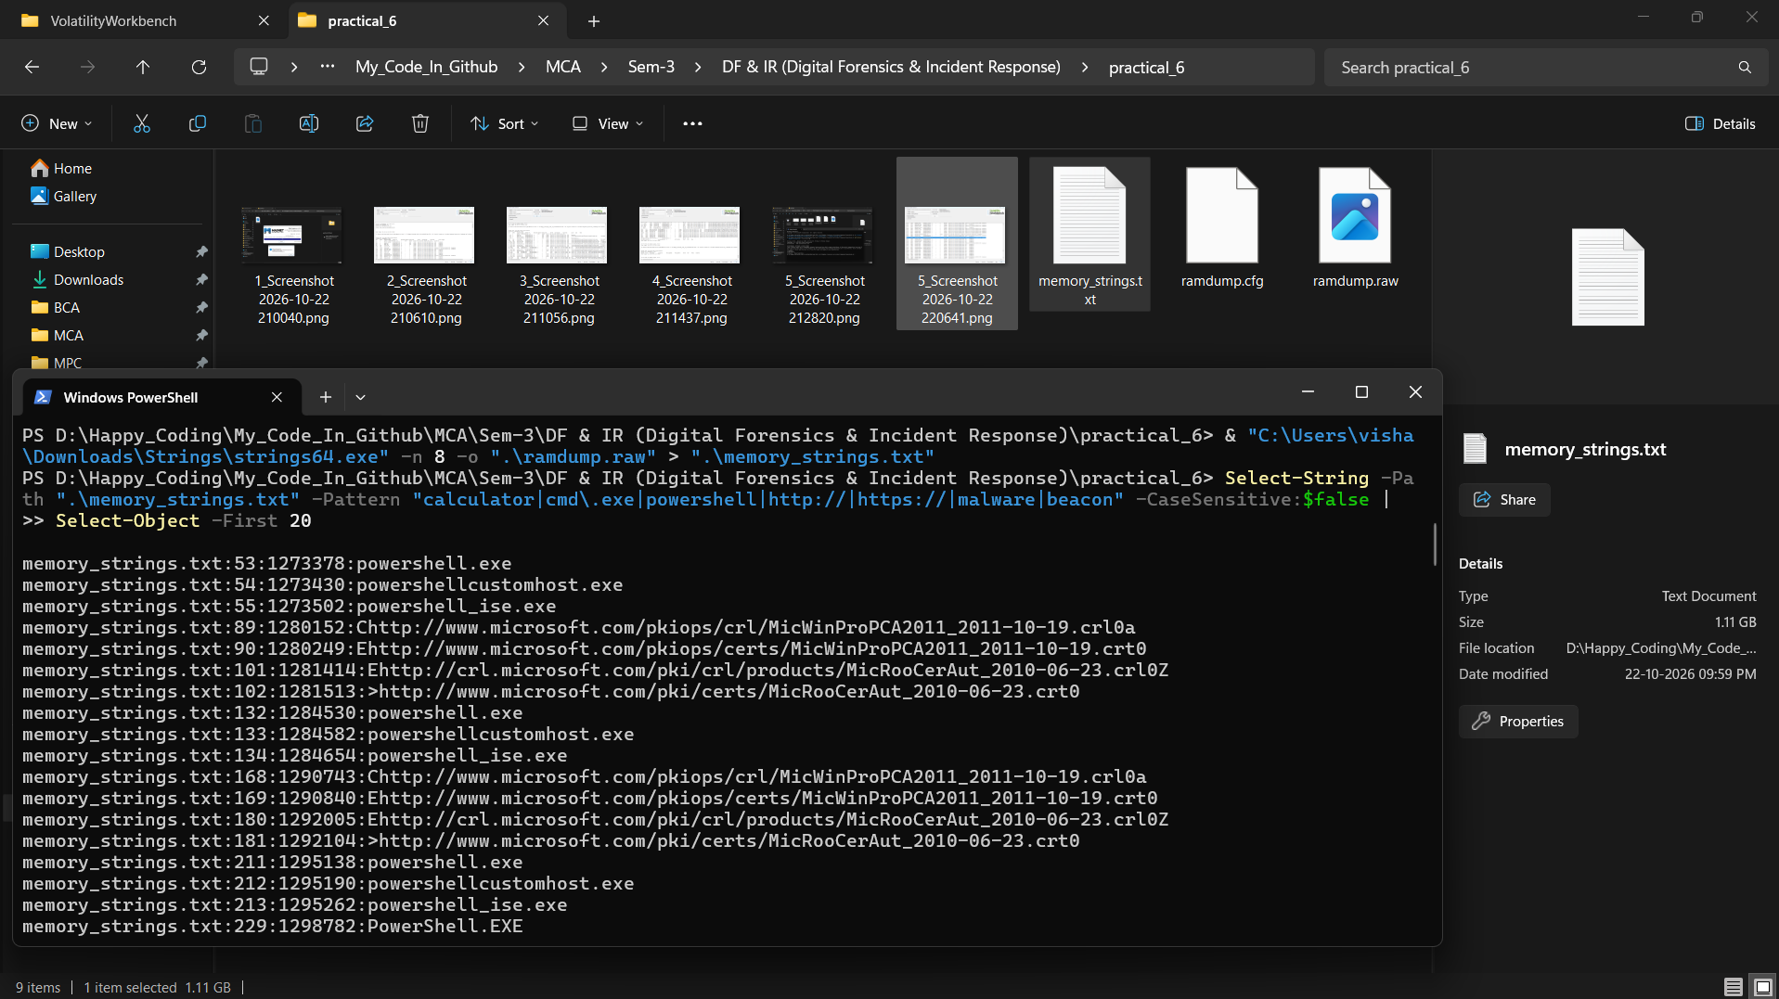
Figure 6: PowerShell displaying the search results from the extracted memory strings.
POC Explanation
The extracted strings included PowerShell-related text, a Windows Calculator package identifier, Microsoft certificate URLs, and other website URLs. No confirmed malware indicators were identified in the available results. Since the extraction was interrupted, the results represent only a partial analysis.

Conclusion
Memory forensics was performed using Magnet RAM Capture, Volatility Workbench, and the Sysinternals Strings utility. The captured RAM image was analyzed to examine running processes, process relationships, network artefacts, and readable memory strings. Although some potentially relevant artefacts were identified, the analysis did not confirm malware infection. The practical demonstrated how memory forensics can support the investigation of system activity and potential security incidents.

Observation
- RAM was successfully captured using Magnet RAM Capture.
- The memory image was saved as ramdump.raw.
- Volatility 3 was used to examine Windows processes.
- The process tree displayed parent-child relationships, including mofcomp.exe.
- NetScan did not recover any network connection entries.
- Memory string analysis revealed system-related text and website URLs.
- No malware infection was confirmed from the available results.

Observation Questions
Q1. Why is cmd.exe spawned from svchost.exe suspicious? What are legitimate reasons?
It may indicate unauthorized command execution by a compromised service. However, legitimate services, software updates, or administrative scripts may also launch cmd.exe. Further investigation is required to determine whether the activity is malicious.
Q2. What malware behavior is suggested by http://malicious-c2.com/beacon?
It suggests possible command-and-control (C2) beaconing, where malware periodically contacts a remote server to receive commands or send information. The URL alone does not prove infection, and this indicator was not confirmed in our collected results.

